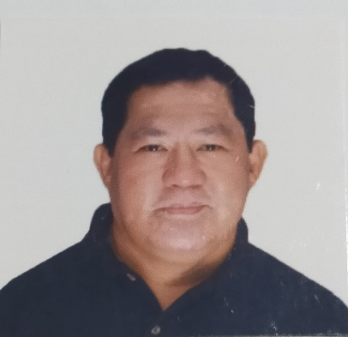

Company
:

RUELITO DUTERTE
SUPREMO

31
Papci St. Anakpawis 2
Westbank
Road Floodway,
San Andres, Cainta
,Rizal, Philippines
(0916)2664113
(0927)9951591
(

supremoruel@gmail
.com

Princess Cruise Lines
Position:  Period Covered:  Job Description:  ▪  ▪  ▪  ▪  ▪ | Chef de Partie  October 29, 2016 – Present  In-charge in the daily operation of Horizon Court Breakfast Buffet Supervises product delivery in assigned Galley Station.  Monitor availability of foods during operation time due to a high volume of passengers (3000 pax).  Continually trains and coaches staffs in correct production method and skills, culinary techniques, menu and recipe knowledge, product holding techniques, presentation and delivery of products.  Ensures compliance with company, safety, environmental USPH and fleet regulations, and ILO 180 Standards.
▪ Assigned in the different stations in the galley. (Garde manger, soup, sauce, grill
and fish station.
WORK EXPERIENCES:

Company: | City of Dreams Manila
Position: | Sous Chef
Period Covered:  Job Description: | July 26, 2014 – September 16, 2016
▪ | Assist the Chef de Cuisine to manage and lead the culinary team in producing the finest culinary experience.
▪ | Manage the kitchen theme to produce consistently high quality food production and presentation in the outlet and the hotel.
▪ | Train and develop Junior Kitchen Staff to operate to the required standard as established by the hotel and Chefs office and keep appropriate documentation.
▪ | Supervising overall kitchen activities including kitchen hygiene, policies and procedures, manpower handling, including daily chef’s briefing.
▪ | Ensure the food cost is in line with the budget as well as kitchen operating supplies, and kitchen energy costs.
▪ | Prepare and control of daily and weekly market list.
▪ | Handle customer comments and complaints, and take swift corrective action to resolve issues to the customers.
Company: | New World Makati Hotel
Position: | Sous Chef
Period Covered: | July 2, 2010 – July 25, 2014
Job Description: ▪ | Responsible in assisting the chef de cuisine to in managing and leading the designated culinary team in producing the finest culinary experiences.
▪ | Attends meeting in absence of the chef de cuisine, ensure that all designated action point on daily chefs’ briefings of monthly operational meetings are being followed by the individual concerned.
▪ | Handle costumer comments and complaints and take corrective action to resolve the issues.
Company: | Isrotel Royal Beach Hotel Eilat, Israel
Position: | Oriental Food Chef
Period Covered: | Sept. 2004-December 2009
Job Description: ▪ | Overall in-charge of all oriental foods (Chinese Cuisine, Japanese Cuisine, etc).
▪ | Relief Cook in most cuisine e.g. European Cuisine, American Grill and Restaurants.
▪ | Handling banquets, e.g. wedding, seminars and others events
▪ | Assists in Kosher food, dairy kitchen and salad section.
Company: | New World Renaissance Hotel - Makati City, Philippines
Position: | Chef de Partie (Chopper #1)
Period Covered: | 1994-2004
Company : | East Ocean Seafood Restaurant – Vito Cruz, Malate,Manila
Position: | Chef de Partie (Wok #2)
Period Covered | 1990-1994

Company: | Gloriamaris Seafood Restaurant – CCP Complex, Manila
Position: | Chef de Partie (Chopper #1)
Period Covered: | 1986-1990

PERSONAL DATA:

Provincial Address: San Francisco, Southern Leyte
Date of Birth: December 01, 1967
Place of Birth: Manila
Height: 5’6” Weight: 90 kgs.
Religion: Catholic
Gender: Male
Citizenship: Filipino
Civil Status: Married
Current Physical Condition: Excellent

EDUCATIONAL BACKGROUND:

Primary : San Francisco Central | Graduated (Elementary Education)
High School: Panaon Institute | Graduated (Secondary Education)
College: University of San Jose- Recoletos | UnderGraduated (BSCE)

CHARACTER REFERENCES:

Mr. Allan Solano Sous Chef Princess Cruise (09085501319)
Mr. Leonilo Dupay Sous Chef Okada Manila (09154200016)
Mr. Guiller Montreras Sous Chef City of Dreams Manila (09277422815)

CONTACT PERSON:
Erlinda Supremo (Mother)
(0936) 305-1630

Ruelito D. Supremo

Applicant’s Name & Signature

