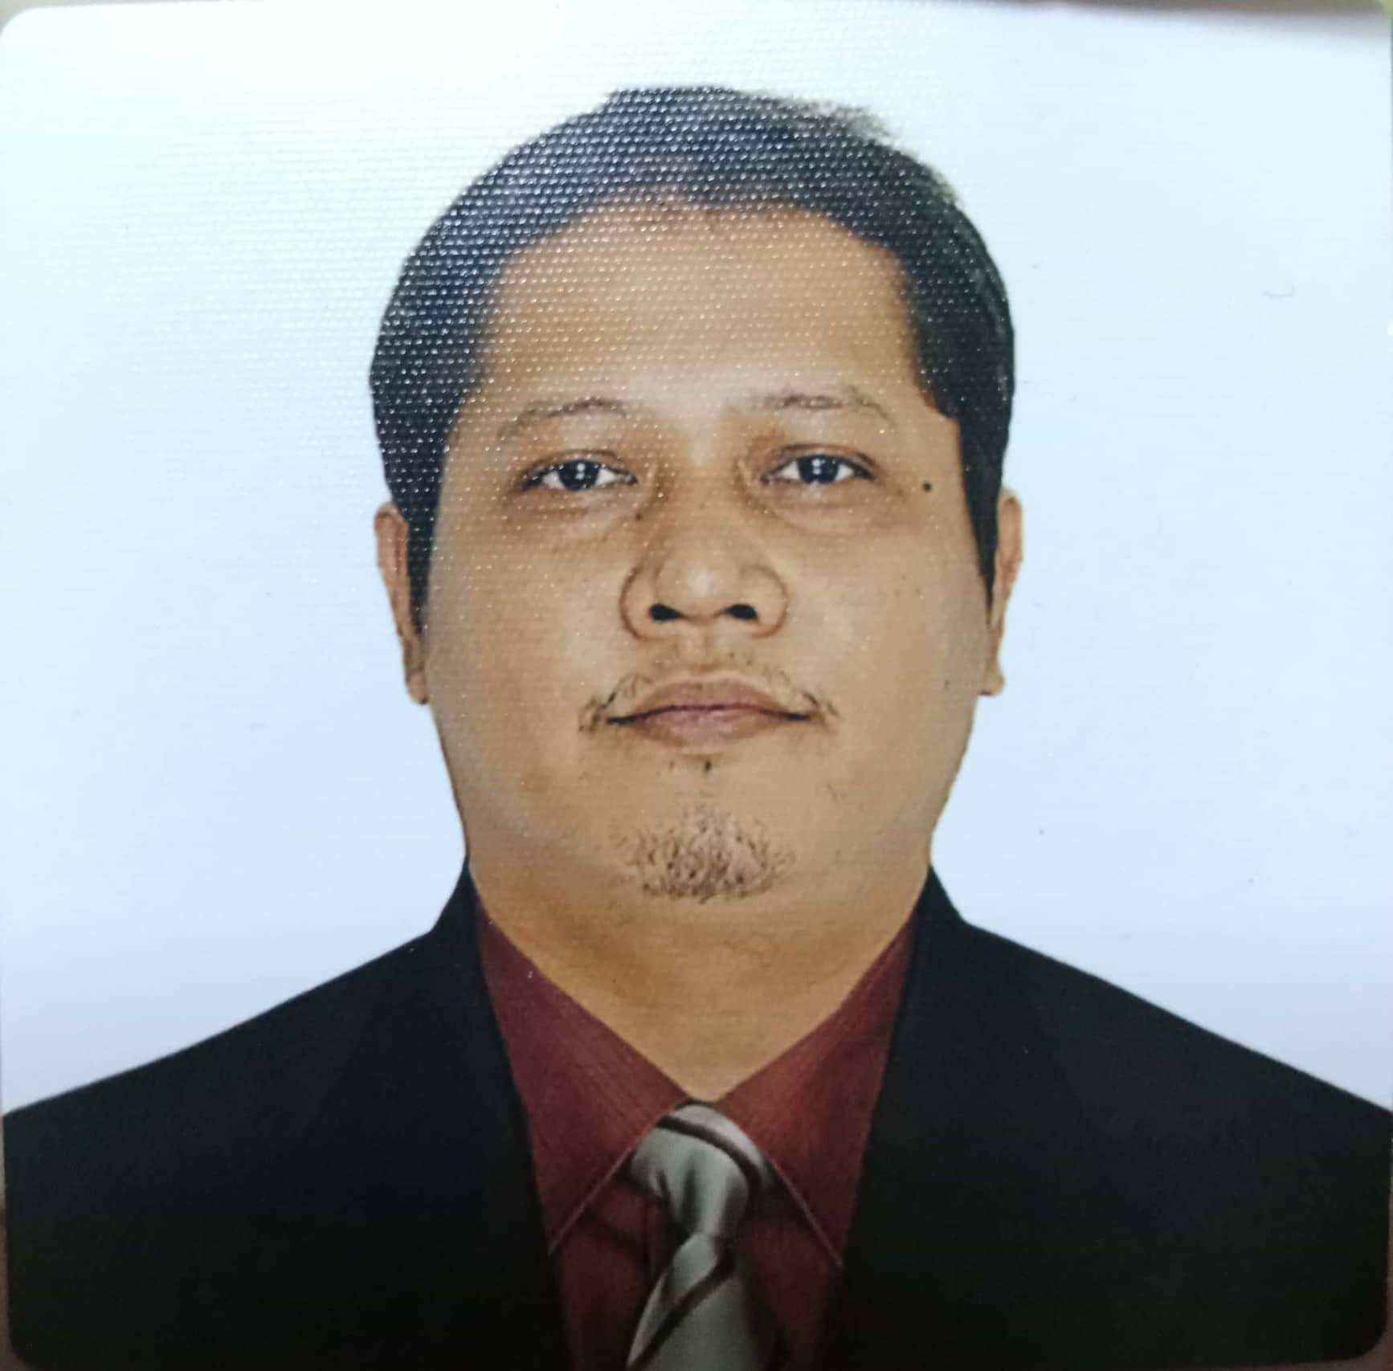
GONZALES, RYLAN DAVE L.
BLK 4 LOT 12 ANCOP CANADA HOMES, Visayas Avenue
Quezon City, METRO MANILA
09081591765, 09281884972, rylandavegonzales@ymail.com

CAREER OBJECTIVE
I offer my services and determination to be an asset to your company throughout the duration of my training period.

EDUCATIONAL BACKGROUND
Ernesto Rondon High School (April 1991 - 1994)

TRAINING/WORK RELATED EXPERIENCE
NCII COOKERY
Crowed Crisis
Basic Training Cruise
USPH TRAINING
Environmental Training

WORK EXPERIENCE
ROYAL CARIBBEAN LTD ( 2008 - PRESENT)
HOLLAND AMERICA LINES ( 2004 - 2007 )
SAISAKI JAPANESE RESTAURANT ( 2000 - 2004 )

SEMINARS ATTENDED
PIDOS
Anti-Piracy

CORE COMPETENCIES
Hot and Cold Cuisine
Japanese Cuisine
Filipino Cuisine
Preparation and Cooking

PERSONAL BACKGROUND
Age: 44 years old
Civil Status: Married
Birthdate: February 15, 1977
Citizenship: Filipino

REFERENCES

Mr. Edwin Magpayo
09989180246
Celebrity Cruises / Sushi Cook
Antipolo City

RYLAN DAVE L. GONZALES
Applicant

