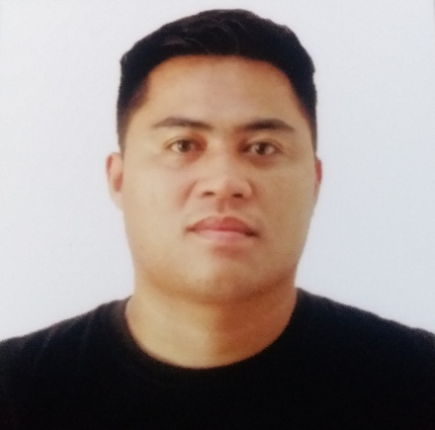
Assistant Cook, Line Cook, Assistant Head Cook Lamesa Grill
Rank in file promotions from Assistant Cook to Assistant Head Cook.
Responsible for the preparation of fresh ingredients to be handed over to the line cook station and is responsible for the daily and monthly inventory.
Responsible for making sauces, dips, cooking what is handed by the assistant cook and making sure to follow every cooking standards.
Responsible for supervising the Kitchen Operations under the supervision of the Head Cook.
Email
jaysondalorayaanos@gmail.com

March 27, 2015-Dec. 20, 2015
SKILLS
CAREER
ACADEMIC
Jan. 9, 2011-
Feb. 27, 2015
Assistant Head Cook Nalusuan Island Resort and Marine Sanctuary
Rank in file promotions from the Chief Steward to Assistant Head Cook
Able to perform all the positions per stations, from Grill, Food Prep., Line Cook to being the Assistant Head Cook with the help of my colleagues and the supervision and guidance of my superiors.

Good work ethics Adaptability Knife Work Leadership
Ala carte and Banquet Cooking Multi-tasking
Mr. Albert N. Amaga
Resort Manager Martessem Mountain Resort
0961-760-5273
Mr. Hedrich V. Mendoza Restaurant Manager Nalusuan Island Resort and Marine Sanctuary 0925-520-5799
2009-2010
2006-2009
2000-2006
Cookery NC II Passer TESDA
Seafaring Specializing in Stewarding Ormoc City Institute of Technology
High School Carigara National High School
Elementary Hiluctogan Elementary School
2016
Jayson has a working experience as a head chef, line cook, assistant cook or any kitchen related positions. Capable of motivating colleagues to perform to the best of abilities across every task. Able and willing to learn new knowledge, new culture and development of career growth and company goals.
PROFILE
Jayson Daloraya Anos
Head Chef, Line Cook, Assistant Cook, Commissary
PROFESSIONAL
Knowledge and Skills on Kitchen Operations
Ability to be responsible on finishing every tasks given.
Able to deal with frequent change or unexpected events.
Building deep and effective relationship with company and peers.
Line Cook and Kitchen OIC Kuya J Restaurant
Responsible for cooking menus according to their standards.
Maintaining the correct level of fresh, frozen and dried foods in store room.
Oversee the preparation of food making sure the proper standards are met.
Head Chef Martessem Mountain Resort
Managed daily kitchen operations with staff members.
Mentored and trained every kitchen staff positions to improve their performance.
Oversaw food preparation and production, ensuring 100% food safety procedures were followed.
Developed entire menu and increase the resort sales.

July 1, 2016- August 31, 2018

January 14, 2019-January21, 2021
Phone
0950-910-4348
0967-581-1738

REFERENCES
Ms. Marilou Javines
Restaurant Manager Kuya J Restaurant
0905-282-4325
CONTACT
Address
Brgy. Hiluctogan Carigara, Leyte



