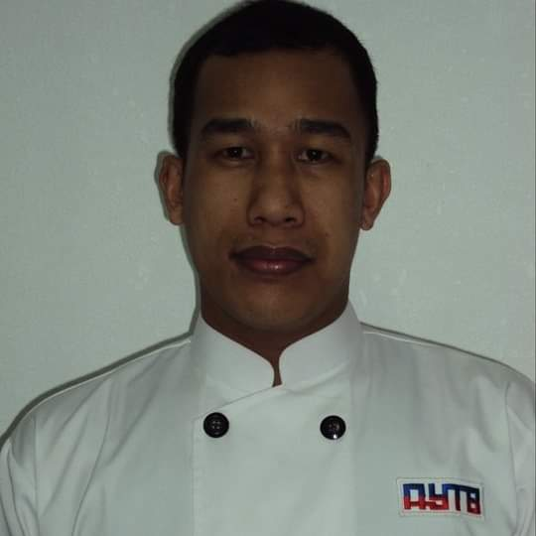
ARVI MICHAEL T. MANUBAG
Contact info: +639164571104
arvimichaelmanubag1982@gmail.com

PERSONAL DATA:
AGE: 39
BIRTHDATE: FEBRUARY 15, 1982
BIRTHPLACE: OZAMIS CITY PHILIPPINES
SEX: MALE
CIVIL STATUS: MARRIED
PERMANENT ADDRESS: P5 UPPER PRINCESA, BAROY, LANAO DEL NORTE

EDUCATIONAL BACKGROUND :
COLLEGE : BACHELOR OF SCIENCE IN INDUSTRIAL TECHNOLOGY
MAJOR IN FOOD TECHNOLOGY
MINDANAO STATE UNIVERSITY
MAIGO, LANAO DEL NORTE
2004-2008 (GRADUATE)
HIGH SCHOOL: LANAO DEL NORTE NATIONAL COMPREHENSIVE HIGH SCHOOL
BAROY, LANAO DEL NORTE
1995 – 1999
ELEMENTARY: SANTO NINO ACADEMY
BAROY, LANAO DEL NORTE
1994 - 1995

JOB EXPERIENCE :
COOK- SUNSET RESTAURANT
KING ABDUL AZIZ ROAD
AL DANAH RASTANURA K. S. A
JULY 13, 2019 TO PRESENT
JOB DESCRIPTION:
- RESPONSIBLE IN THE PREPARATION OF RAW MATERIALS NEEDED FOR BURGERS
- RESPONSIBLE IN PREPARING SAUCES AND DRESSINGS
- RESPONSIBLE IN THE CLEANLINESS AND SANITATION OF THE KITCHEN

KITCHEN SUPERVISOR - EZER FOOD ENTERPRISE
HAYES ST. CAGAYAN DE ORO CITY
JANUARY 2016 TO JANUARY 2018
JOB DESCRIPTION :
- RESPONSIBLE IMPLEMENTING RULES AND STANDARD OPERATING PROCEDURES
- RESPONSIBLE IN MAKING SCHEDULES FOR KITCHEN STAFF
- MONITOR KITCHEN STAFF ATTENDANCE AND PERFORMANCE
- RESPONSIBLE IN HIRING STAFF DURING INTERVIEW
- RESPONSIBLE IN THE REQUISITION OF KITCHEN SUPPLIES

CHIEF COOK- AL YUSR TOWNSEND AND BUTTOM CO. LTD.
JUBAIL INDUSTRIAL CITY K. S. A
AUGUST 2007 TO OCTOBER 2015
JOB DESCRIPTION :
- DEVELOP AND PLAN DAILY MENU
- RESPONSIBLE IN THE REQUISITION OF NEEDED KITCHEN SUPPLIES
- MANAGE FOOD COSTING AND INVENTORIES
- MAINTAIN STANDARDS FOR FOOD PREPARATION AND STORAGE
- ESTABLISH MAINTENANCE AND CLEANING SCHEDULE FOR EQUIPMENT, STORAGE AND WORK AREAS
- RESPONSIBLE IN MONITORING KITCHEN STAFF ATTENDANCE AND PERFORMANCE

