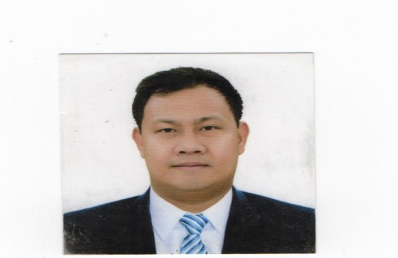



PERSONAL SUMMARY:
- In-charge of Food exchange ala carte, Gourmet bar, Pool bar, Sabor.
- Seeks opportunities to increase food revenue, decrease kitchen expenses, wastages and maximize departmental productivity without compromising guest satisfaction and quality of food item to avoid loss of profit.
- Promotes health and safety at all times, Responsible for distribution of staff responsibility, schedule, training, briefing as well.
- We had 396 rooms and can accomodate 3000 function by our grand ballroom Monet 1, 2, 3 and Pool bar anahaw as well Versailles Garden for wedding.
- Handled 2000plus function last 2019 with our very own special menu pica-pica.
- In-charged of ViP/VViP and Owner to create a fine dining experience.

- HABC Level 2 Award in food safety in Catering
(QCF)June 16, 2014.
- Holland America Line : Basic Environmental Management Training : April 12, 2012
- Holland America Line : STWCD Basic Safety Familiarization and Crowd Management Training : April 12, 2012
- Philippine Culinary Cup: Participated Sous Vide category. August 08, 2019
SMX Convention Center, Pasay City, Philippines
- Keys to communication/Heartist Training)Elaine Fernando/Jc Cabrera(November 04, 2019)
Novotel Manila Araneta City.
- Barilla Master of Pasta Training by:
Chef Andrea Tranchero/March 03, 2020
Marriott Manila.
- All Safe Training by Accor. July 2020

NOVOTEL MANILA ARANETA CITY| CHEF DE PARTIE

Quezon City, Manila Philippines (May 08, 2017 – December 31, 2019)
- Daily checking of mise en place to ensure freshness and quality standards.
- In-charge of Food Exchange Manila if the Chef de Cuisine is not around, Creates memorable dining experiences and satisfaction for all guests.
- Follows high quality of food standard and recipes.

EMIRATES FLIGHT CATERING| SUSHI CHEF

Dubai, United Arab Emirates (June 08, 2014 – March 08, 2017)

- We cater and served all sushi and shashimi item for Emirates first class passenger.
- Follows health, safety and HACCP guidelines as per Dubai Municipality.
- Responsible for mise en place of all sushi item such as, cutting fish, maki and shashimi.

HOLLAND AMERICA LINE/UPL|GPA-PANTRY/GARDE MANGER

Amsterdam, Netherland (April 15, 2012 – October 31, 2012)

- Maintain high level of productivity, hygiene, cleanliness and sanitation throughout the operationand areas of responsibility at all times USPH standard.
- Responsible in assisting for all the food preparation in accordance of established company’s menu and recipes.

Doha, Qatar (May 2007 – May 2008)
- Responsible of cooking different kind of sauces, rice, pasta and soup, follow as high quality of food standard and preparation, Maintaining standard of safety and hygiene,
- Monitors the quality of raw material to be used in the operation such as vegs. Seasoning, meats, poultry etc.

DIET DELITE/PREMIUM WELLNESS COMPANY| HEAD COOK

Riyadh, Saudi Arabia (November 05, 2009 – November 16, 2011)

- Monitors the quality of raw materials such as meats, vegs. and dry items.
- Creating new recipes to be used in the restaurant for food tasting and menu.
- Maintaining the standard of safety and hygiene in the work station.
- Follows high quality of food standard and preparation with a minumum wastages.

APPLEBEE’S INTERNATIONAL/FOODVEST W.L.L/ LINE COOK

NOVOTEL MANILA ARANETA CITY| SOUS CHEF

Filipino/Tagalog: Native
CHARACTER REFERENCE:
Executive Chef/Massimiliano Pauletto
Massilmiliano.PAULETTO@accor.com
Contact#: 09989675075
Chef De Cuisine/Michael Ramos
Contact# 09988458223

Arabic: Beginner
English: Advanced
LANGUAGES:

with 13 years experience working in the food industry, started as dishwasher in fast food chain and pursue his career working abroad, a team player and self motivated person, who works hard to earn appreciation and criticism, has passion for food and cooking, strives for excellence and quality of works. Never stop learnjng and gain knowledge from different people that his working with, easy to adapt culture and fast paced environment. He loves to express the way of cooking by sharing his passion and creativity towards work and endeavor.
SKILLS, TRAINING, EXPERTISE:

- Excel
- Word
- PowerPoint
- Outlook
SOFTWARE:

ejohngharon@gmail.com
email

Block 4 lot 52 Nouveau Residences, Pulung Cacutud Angeles City, Pampanga

+(639)661690996

CONTACT:
Quezon City, Manila Philippines (January 01, 2020 – Present)
Executive Chef/ Massimiliano Pauletto
General Manager/Mike Brown- Maria Garcia

WORK EXPERIENCE:
ENRIQUE JOHN F. GARON

- Donecturpis mauris, auctor vitae sollicitudin in, elementumefficiturtellus.
- Aeneannecturpis tortor. Ut placeratvariusvivera vestibulumeudictumpurus.
- Ut lacinia commodo erat id vulputate. Orcivariusnatoquepenatibus et magnisdisparturient montes, nasceturridiculus mus.

