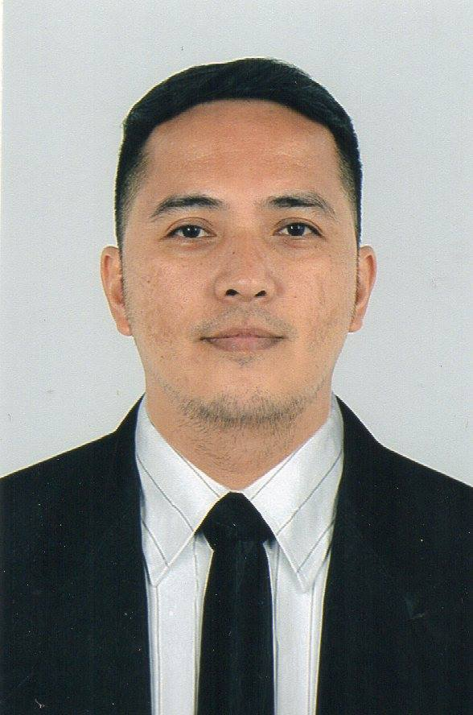
PERSONAL DETAILS
Name: Robert Conrad P. Colonia
Birthdate: September 08, 1976
Birthplace: Manila, Philippines
Address: 160-c Alpha st. Bangkulasi Navotas City
Sex: Male
Tel. no: 02 2812991
Mobile no: +639563895247
E-mail: robertcolonia76@gmail.com

PERSONAL PROFILE
I would describe myself as well presented hardworking individual who thrives at the chance of learning new skills. Have worked in a hotel, restaurant, international passenger ship and roro/passenger vessels for seventeen years spotlessly. I have gained excel
lent communication skills and enjoy working with the public. I always like to work quickly but neatly so I can get the task I have been given done in a professional and efficient man ner. Working with colleagues and customers in stressful environments has helped me build my confidence as a person and hopefully will carry on so. I am also willing to take any ne cessary trainings to enable me to carry out my work well.
- Well groomed and neat appearance
- Flexible
- Amazing ability to walk, sit and stand for a long time w/o getting tired
- Social skills
- Interpersonal skills
- Punctual

OBJECTIVES
I am seeking the opportunity of working for a renowned company such as yours in any available position that would best fit my experiences and qualifications.

EDUCATIONAL BACKGROUND
BS HOTEL AND RESTAURANT MANAGEMENT
Philippine Women's University
June 1995 to March 1999

WORKING EXPERIENCES
Assistant Restaurant Waiter
August 6, 2019- March 19, 2020
Fred Olsen Cruise lines/
Bahia Shipping Services Inc.

5th Floor Ma. Daniel Bldg.
470 San Andress cor M.H.
Del Pilar St. Malate, Manila,
Philippines
0285217456

Assistant Restaurant Waiter
October 4, 2018- May 18, 2019
Fred Olsen Cruise Lines/
Bahia Shipping Services Inc.
5th Floor Ma. Daniel Bldg.
470 San Andress cor M.H.
Del Pilar St. Malate, Manila,
Philippines
0285217456

Restaurant Steward
April 10, 2017- October 3, 2017
Scanmar Maritime Services
G/F Royal Enterprises Bldg. 2227 Chino Roces Ave. Makati City Phil.
0288191013-17

Restaurant Steward
September 27, 2016- November 23, 2016
Scanmar Maritime Services
G/F Royal Enterprises Bldg. 2227 Chino Roces Ave. Makati City Phil.
0288191013-17

Waiter
November 02, 2015- March 22, 2016
Elburg Shipmanagement Inc.
16th Floor Axa Life Center Gil Puyat Ave. Makati City
0288170971-75

Waiter
December 02, 2014- April 08, 2015
Elburg Shipmanagement Inc.
16th Floor Axa Life Center Gil Puyat Ave. Makati City
0288170971-75

Waiter
March 05, 2014- August 18, 2014
Elburg Shipmanagement Inc.
16th Floor Axa Life Center Gil Puyat Ave. Makati City
0288170971-75

Waiter
July 15, 2013- December 02, 2013
Elburg Shipmanagement Inc.
16th Floor Axa Life Center Gil Puyat Ave. Makati City
0288170971-75

Waiter
December 05, 2012- April 29, 2013
Elburg Shipmanagement Inc.
16th Floor Axa Life Center Gil Puyat Ave. Makati City
0288170971-75

Waiter
March 05, 2012- September 26, 2012
Elburg Shipmanagement Inc.
16th Floor Axa Life Center Gil Puyat Ave. Makati City
0288170971-75

Waiter
April 01, 2011- October 01, 2011
Elburg Shipmanagement Inc.
16th Floor Axa Life Center Gil Puyat Ave. Makati City
0288170971-75

Waiter
June 24, 2010- November 19, 2010
Elburg Shipmanagement Inc.
16th Floor Axa Life Center Gil Puyat Ave. Makati City
0288170971-75

Waiter
June 11, 2009- March 10, 2010
Jebsen Maritime Inc.
2nd Floor Harbor Center, South Harbor Port Area Manila City
0285279980

Assistant Waiter
June 12, 2008- November 15, 2008
Magsaysay Maritime Corp.
TM Kalaw st. U.N. Avenue Manila City
0285268888

Assistant Waiter
January 04, 2008- April 09, 2008
Magsaysay Maritime Corp. Magsaysay Maritime Corp.
TM Kalaw st. U.N. Avenue Manila City
025268888

Housekeeping Utility
July 06, 2007- January 03, 2008
Magsaysay Maritime Corp.
TM Kalaw st. U.N. Avenue Manila City
0285268888

GPA Cleaner
March 23, 2006- November 05, 2006
Magsaysay Maritime Corp.
TM Kalaw st. U.N. Avenue Manila City
0285268888

GPA Cleaner
April 15, 2005- October 19, 2005
Magsaysay Maritime Corp.
TM Kalaw st. U.N. Avenue Manila City
0285268888

GPA Cleaner
December 15, 2003- October 05, 2004
Magsaysay Maritime Corp.
TM Kalaw st. U.N. Avenue Manila City
0285268888

SKILLS AND INTEREST
Table setting, Coffee making, Napkin folding, and Bedmaking

CERTIFICATES HELD
National Certificate 1 Messman ( NC1 ) March 19, 2018
Basic Training ( Refresher) March 06, 2018
Food safety Level 2 May 05, 2017
Crisis Management ( Updating ) March 31, 2017
Crowd Management ( Updating ) March 24, 2017
Crowd Management September 10, 2016
Crisis Management September 08, 2016
PSCRB (COP) June 27, 2016
Shipboard Housekeeping and Stewarding Course November 15, 2014
Ship Security Awareness Training and Seafarer with January 29, 2014
Designated Security Duties ( SSA and SDSD )

Italian Law July 11, 2013
ILO/ MLC July 10, 2013
Proficiency in Fast Rescue Boats ( PFRB ) June 13, 2013
Shipboard Safety Culture November 28, 2012
Anti-piracy Awareness Seminar November 27, 2012
Maritime English November 26, 2012
HACCP November 23, 2012
Certificate of Competency Messman ( COC ) March 02, 2011

CHARACTER REFERENCES
Ms. Noriela Leonidas
Vice-President
Magsaysay Maritime Corp.
025268888

Ms. Julieta Joson Bautista
Fleet Manager
Scanmar Maritime Services
028191013-17

Ms. Irish Rempillo
Fleet Manager
Elburg Shipmanagement Inc.
028170971

Mr. Jonald Cabunoc
2nd Steward ( Norwegian Cruise Line )
CF Sharp
025276031

Mr. Jose Bras
Hotel Manager
MV Hamburg
Ligabue Catering Swiss
Mr. Klaus Reinmueller
Food Manager
MV Aegean Odyssey
Ligabue Catering Swiss

Mr. Denis Kolashnikov
Headwaiter
MV Aegean Odyssey
Ligabue Catering Swiss

Sworn and declared that all information stated above is true and correct…

Robert Conrad P. Colonia

