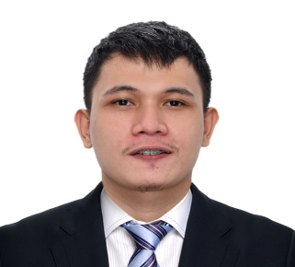

allan maas
06 G Sampaguita St., Western Bicutan, Taguig City · 09511149085
Email · allanmaas1020@gmail.com
 | A highly motivated, detail-oriented and friendly individual with five years of experience providing customer service, preparing food and ensuring restaurant environments are clean and safe seeking for a position as a cook.
 | Experience

MARCH 2019 – January 2021

LINE COOK, Tito Chef Restaurant and all things culinary
Responsible for plating and food preparing.

June 2016 – To january 2019

COOK, Matsuri Yakiniku BBQ and Soul Foods by Tito Chef
(SUSHI BAR)
 | Education

June 2012 – april 2016

bachelor of Science in Hotel and Restaurant Management, Taguig City University

March 2018 – OCTOBER 24, 2020

Culinary arts & diploma, Professional Academy for Culinary Education

 | Skills competencies
 | - Basic culinary terms and techniques  knife skills (different cuts and terms)  - Attention to details.  - Time management  - Proper hygiene in the kitchen  - Communication skills  - Advance plating  - Skills in fabricate fish & poultry  - Ability to make the different kinds of salad dressing. | - Goal Oriented  - Flexible and adapted to change  - Detail oriented  - Multitasking  - Learner
 | Activities/trainings
TRAINING / WORKSHOP:
• Certificate of Appreciation (Judge in Mystery plate CHTM’s Nihongo festival)
o May 4 – 5 2018
• Certificate of Appreciation (Guess speaker in Sushi and Maki demonstration during Nihongo festival 2018)
o May 5, 2018
• Competency and empower toward innovation and ASEAN integration of hospitality industry
o Taguig City University
o February 9, 2015

CHARACTER REFERENCE:
Ching Baliling
HRD Secretary Kitchen Manager The
Heritage Hotel Manila,
Roxas Boulevard Corner EDSA, Pasay City 09176364508

John Chester T. Alcedo
Waiter team Leader
Ramen Nagi Philippines / Ayala Malls The 30th
09058545253

