DAVID B. VALENZUELA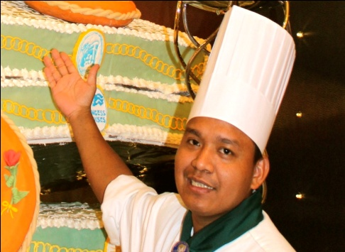

APPLYING FOR : PASTRY CHEF

#312 Country Vill. Sub. Bari Mangaldan Pangasinan contact# 09388608863 email: Valenzuelasr17@gmail.com

CAREER GOAL: PASTRY CHEF/ASSISTANT PASTRY CHEF/CAKEDECORATOR

An experienced Pastry Chef/Cake Decorator seeking a full-time position in a well established hotel, cruise line, yacht, restaurant or patisserie to enhance my skills and create visually appealing and delicious desserts.

EXPERIENCE
VIKING RIVER CRUISE Pastry Chef May 28 2015 to Present
OCEANIA CRUISE LINE/APOLLO SHIP CDP Pastry May 16 2014 to March 28 2015 Asst. CDP Pastry July 10 2013 to March 23 2014

- Follow all standardized decorations and motifs of cakes.
- Checks station upon arrival to determine status of safety or equipment issues.
- Responsible for delivering products of the highest quality in terms of creativity.

Holland America LinesINternational
Asst. Pastry Chef November 2007 to March 2013

- Responsible for day to day operations of the pastry team.
- Work closely with the assistants for the necessary preparation of the menu.
- Actual plating of the desserts at the time of order.
- Consistently checks temperature in foods and follows proper procedures.
- Ensures Consistently checks temperature in foods and follows proper procedures.
- signs bake and garnish cakes and pastries for all the shops all products are prepared fresh and is of highest quality.
- Designs bake and garnish cakes and pastries for all the shope.
- Prepares and bakes cakes, desserts or puddings according to the recipe.
- Responsible for procuring “mise-en-plus”.
- Assist on the preparations of all pastry products made onboard the shope.
- Creative planning, control and overall management during dessert projects.
- Working with various cake ingredients as well as toppers, icing and other edibles.
- Suggesting additional creative ideas when decorating and frosting cakes.

holland america lines international
Panty Man September 2006 to September 2007 . . Responsible for all mise –en- plus in my station.
Prepares planning of food to passenger
CHOWKING FOOD CORPORATION
Head cook August 2003 to August 2006
Overall in charge in the kitchen InchargeOrdering , scheduling and Food cost of the Restaurant.
CHOWKING FOOD CORPORATION
Cook 1 & Cook 2 November2002 to August 2003 Kitchen StaffFebuary2000 to April 2003 PHILIX MININGCORPORATION Electrician January2000 to May 2000

EDUCATION

MANANTAN TECHNICAL SCHOOL

- Electrical Technology
- Graduate

TRAININGS AND SEMINARS ATTENDED

United Philippines Lines Training Center Manila, Philippines
- National Certification 2 & 3
- Culinary Training Basic Baking and Cake Decorating
- USPH Basic Sanitation training
- Anti-Piracy Awareness Training Seminar
- Basic Safety Familiarization and Crowd Management Training
- Basic Environmental Management System Training
- Crowd and Crisis Management training
- MARLINS English Language Proficiency
- Managing the Kitchen training
- Effective Leadership Training
- Basic Equipment
- Maintenance Training

FAR EAST MARITIME San Fabian Pangasinan, Philippines
- Advanced Training in Fire Fighting

The Maritime Training Center of the Philippines Manila, Philippines
- Proficiency in Survival Craft and Rescue Boat
HOLLAND AMERICA LINE INTERNATIONAL Onboard Training
- Crowd Management Training
- Training Program for United States Public Health
- Crew Safety and Security Awareness Training
- Drugs and Narcotics Policy Seminar

PERSONAL PROFILES

Date of Birth:
- Jan. 17 1981
Civil Status:
- Married
Citizenship:
- Filipino
Passport:
- PO246245valid from 15 JAN 2019 to 14 JAN 2029
Seafarer’sIdentification and Record Book:
- C1534710valid from 19 DEC 2019 to 11 DEC 2029
Seafarer’s Registration Certificate:
- Rank/Rating PASTRYMAN
- SF1137906issued on DEC 23, 2010

I hereby certify that the information is true and correct to the best of my knowledge and belief.

Applicant’s Signature

