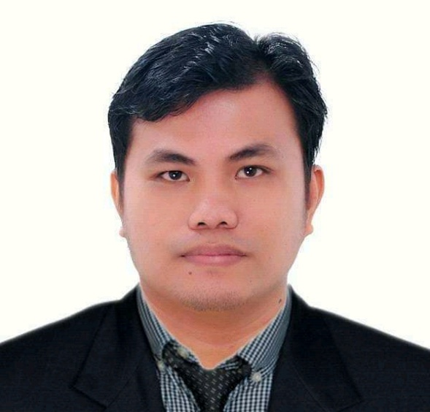
ROLDAN N. SALTIVAN
BACHELOR OF SCIENCE IN- ELECTROMECHANICAL TECHNOLOGY
AL WATANIA VILLA NEW INDUSTRIAL AREA RIYADH SAUDI ARABIA
MOBILE: +639106139316/+639107738317/0565396949

OBJECTIVE:
To be a member of prestigious company where in I can apply my knowledge
And skills gathered during my formal education and working experience.

FROFILE SUMMARY:
- One year and till now Experience as Machine Operator at Can Manufacturing here in Riyadh Saudi Arabia in Al Watania For Industries.
- Three years and till Now Experience as Maintenance Technician/Sime- Automatic Seamer in Tin-Can’s & Metal Sheets Manufacturing Company.
- Eight months experience as Production Operator of Electroplating AU/CU in Electronics Company.
- Six Months experience as CNC Production Operator at Auto Electrical Company.
- Six Months experience as Maintenance/Electrician at Cold Storage Company.

KEY SKILLS AND COMPETENCIES:
- Knowledge in Troubleshooting Seme -Automatic Seamer Machine
Shin-I, Angelus, Canomat and Manual Seamer.
- Can handle and operate plating machine, stripping and etching.
- Able to manage time during manufacturing process and produce quality products.
- Good communication and organizational skills.
- Ability to learn and grow.

Work experiences:
Company Name: Al Watania for Industries
From: Feb, 17,2020 to Present
Address: Riyadh 1st Industrial city,Riyadh Kingdom of Saudi Arabia
Position Held: Seamer Machine Operator
Product: Tin-Can’s,

Duties and Responsibility
- Check machine before start up
- Monitoring and Visual checking on body of the can
- Check damage can and report to technician emediatly.

Company Name : UNITED CONTAINER CORPORATION.
From : May 13, 2016 to Feb,06,2020
Address : Llano Road Brgy, 167 Llano Caloocan City Metro Manila
Position Held : Maintenance Technician/Semi- Automatic Seamer Machine.
Product. : TIN-CAN’S, CARROGATED BOX,HDPE PLASTIC BOTTLE.

Duties and Responsibility’s:
- Check the Seamer Machine before Start up, the Seaming roll, Seaming chuck, the Entrance and Exit Guide, of The Seamer Machine. Also Troubleshoot The Seamer Machine if there is Problem during Production time.
- Check the Can body dimension using Caliper and Micro-Meter.
- Lubricate all grease fittings located in inner parts and outer parts of the machine also
- Visual inspection on metal can’s at the production line to ensure good quality of the products. And
- Always Monitor the Seamer Machine Daily.

Company Name : TONG HSING ELECTRONICS (PHILIPPINES), INC.
From : January 25, 2015 to September 25, 2015
Address : Plant 2 Prosperity Avenue Carmelray International Business Park , Canlubang, Calamba City, Laguna.
Position held : Plating and Striping Etching production operator
Department : PCB Assembly Line
Products : IC,PCB,LED
Duties and responsibilities:
- Monitoring of produce products.
- Visual inspection of product output. to ensure good quality

Company Name: LAGUNA AUTO PARTS MANUFACTORING CORP. (LAMCOR)
Position : Machine Operator
Department : Production Line
Section : 8GMI 3 (Stator & Alternator assembly)
From : November 23, 2011 to April 20, 2012
Address : Laguna Techno Park, Sta. Rosa Laguna
Product. : AUTO ELECTRICAL PARTS, STATOR,ALTERNATOR.

DUTIES AND RESPONSIBILITY’S:
- Ensure the quality of stator and alternator during production time
- Ensure the good and quality of product output.

Company Name: KEENWOOD COLD STORAGE
Position : Maintenance/ Electrician
Department : Electrical
From : April 10, 2010 to October 29, 2010
Product : MAGNOLIA CHICKEN.

DUTIES AND RESPONSIBILITY’S:
- Always check the voltage drop at the Main Control room to ensure the electrical output distribution.
- Also analyze the frequency data before restarting the main power source.

SPECIAL SKILLS:
- Knowledgeable in Overhauling Sime Automatic Seamer Machine.
- Knowledgeable in Industrial Equipment machine.
- Knowledgeable in Industrial operating Machine.
- Knowledgeable in electrical wiring diagram and installation.
- Knowledgeable in mechanical and automotive assembly.
- Knowledgeable in basic electronics and diagram reading.
- Knowledgeable in basic house wiring installation.
- Knowledgeable in basic welding process.

EDUCATIONAL ATTAINMENT:

Tertiary : DON MARIANO MARCOS MEMORIAL STATE UNIVERSITY
San Fernando City, La Union
2012
Degree : BS. ELECTRO-MECHANICAL TECHNOLOGY

Secondary : SAINT NICHOLAS CATHOLIC SCHOLL OF ANDA
Anda, Pangasinan
2003

Primary : ANDA CENTRAL SCHOLL
Anda, Pangasinan
1999

PERSONAL INFORMATION:

Date of Birth : February, 17, 1986
Place of Birth : Anda, Pangasinan
Age : 33
Gender : Male
Citizenship : Filipino
Civil Status : Marriage
Religion : Roman Catholic

I hereby certify that the above information is true and correct to the beast of my knowledge and beliefs.

Roldan N. Saltivan

