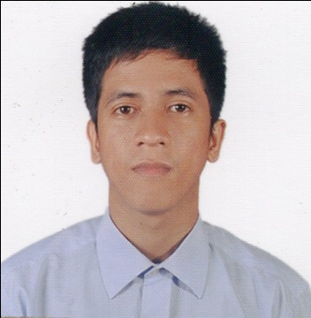
Diego V. Joven Jr
Address: Villa Cuana III Phase 1, Sandoval Ave. Pinagbuhatan Pasig City
Email Address: diegojoven026@gmail.com
Number: 09517750264

Objective: To find a job that will suit my skills and capabilities and to expand all
the skills obtained in the college years and apply it in the field to
benefit the company.

Summary of skills:
*Efficient and well organized
*Hard working and flexible

Personal Information:

Date of Birth : December 29, 1993
Place of Birth : Magarao Camarines Sur
Sex : Male
Civil Status : Single
Height : 5’3
Nationality : Filipino
Fathers Name : Diego R. Joven SR.
Occupation : Farmer
Mothers Name : Lolita V. Joven
Occupation : Housekeeper
Their Address : Magrao Camarines Sur

Educational Background

Elementary: Barobaybay Magaro Elementary School
Magarao Camarines Sur
(2006-2007)

Secondary: Northern Canaman High School
Canaman Camarines Sur
(2013-2014)

Vocational: Shielded Metal Arc Welding (SMAW NC-11)
Tesda, San Jose, Pili Camarines Sur
(2014-2015)
Employment Record

(Present work backward)
Position Company Address
Full Welder Fabricon Steel And General Calamba City Laguna
Engineering Works
Full Welder HHIC-Phil Subic, Zambales

Painter FGU Builders Inc. & co. Parang,marikina city
Character References

Hon. Jose J. Cabrera
Barobaybay, Magarao Camarines Sur
Punong Barangay

I hereby certify that the above information is true and correct to best of my knowledge and belief

________________
Applicant Signature

