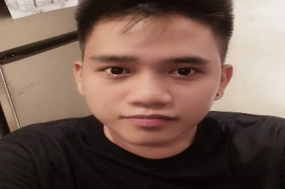
Russel V. Faurillo
Address: #46B Sunflower St. Payatas A. Quezon City
Contact No.: 09567269704

Career Objectives:

Seeking for long term employment in an organization where I can grow professionally and further enhance my skills, knowledge and experience to face and overcome the challenges of today’s changing work environment.

Employment Record
Pancake House
Kitchen Staff/Team Supervisor
Loyola Heights Katipunan Ave.

Ikkorya Fukuoka Ramen
Kitchen Staff
EDSA Shangrila

Willy and Son’s Corporation
Promodizer
GOA, Camarines Sur

Skills
- Attention to detail
- Ability to multi-task and prioritize
- Can handle pressure
- Dedicated to quality

Seminar Attended
- Symposium on Health and Nutrition
- Seminar Workshop on Campus Journalism
- Food Fortification Research Seminar
- Bigg’s Production

Educational Background
Partido State University (2008-2015) Bachelor of Science in Nutrition and dietetics
Lagonoy, Camarines Sur
Lagonoy High School (2004-2008)
Lagonoy, Camarines Sur

Lagonoy Central School (1998-2004)
Lagonoy, Camarines Sur

Personal Data
Mother’s Name: Joy Villete Verdadero
Father’s Name: Danilo Abante Faurillo
Date of Birth: April 4, 1992
Place of Birth: Lagonoy, Camarines Sur
Nationality: Filipino
Civil Status: Single
Gender: Male
Height: 5’5
Weight: 67
Language: Tagalog & English

Character References:
Mary Joy Salvadora. Mrs. Jane Cortez Luzano
09666509207 09672898418
Cashier Store Manager

Angelica Linzo
09276371561
IT Desktop Support

I hereby certify that the above information is true and correct to the best of my knowledge and abilities.

RUSSEL V. FAURILLO

