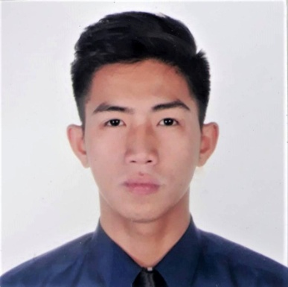
LAWRENCE T. BIADANG
Poblacion, Municipality of San Gabriel, La Union
0977 127 8611
lawrencebiadang@gmail.com

JOB OBJECTIVE
To obtain a responsible and challenging job where I could enhance my knowledge and skills as well as to develop my personality as a future career-oriented person.

EDUCATIONAL BACKGROUND
Tertiary | Bachelor of Arts in Political Science  Saint Louis College  Carlatan, City of San Fernando, La Union  2012-2016
Secondary | Union Christian College  San Fernando City, La Union  2008-2012
Elementary | San Gabriel Central School  San Gabriel, La Union  2002-2008

SCHOLASTIC ACHIEVEMENT
- Activity Grant Scholar: Year 2014-2016
- Gawad San Luis Awardee Excellence in Sports: Year 2014-2016

COLLEGE ACTIVITIES
Organization:
- Political Science Academic Society
- Samahang Makabayan
- Speech and Debate Society
- Order of DeMolay International

WORK EXPERIENCE
- DILG Field Enumerator,
Research on Citizen Satisfaction Index
Year 2015

- Customer Service Associate
Convergys Baguio City
August 2016-February 2017

- Sales Executive
Laus Group of Companies - Hyundai La Union
August 2017-March 31, 2019

- Hyundai Service Advisor for General Job and Preventive Maintenance
Laus Group of Companies - Hyundai La Union
April 1, 2019- present
SEMINARS AND TRAININGS ATTENDED

- 7th Leadership Training Camp
Sponsored by Order of DeMolay Philippines, Pangasinan Chapter and Dagupan DeMolay Alumni Chapter No. 10
Holy Family Garden Resort, Bonuan Binloc, Dagupan City, Pangasinan
April 21-23, 2017

- Enhancing the Civil Society Organization’ Engagement in Local Governance in the City of San Fernando, La Union
Sponsored by the Department of the Interior and Local Government
Saint Louis College, City of San Fernando, La Union
July 30-31, 2015

- Peace Forum on Bangsamoro Basic Law
Social Center, Saint Louis College, City of San Fernando, La Union
July 22, 2015

- SEAOIL- JESSE ROBREDO: Emerging Leaders Camp- Northern Luzon
Sea and Sky Hotel and Restaurant, City of San Fernando, La union
September 26-28, 2014

PERSONAL DATA
Birthdate | January 12, 1996
Place of Birth | San Gabriel, La Union
Age | 25
Civil Status | Married
Religion | Anglican

REFERENCES

Dr. Joseph M. Cristobal
Department Head, Social Science
Saint Louis College
09771320415

Mr. Jonald Carrera
Political Science Instructor
DMMMSU
09399188641

Dr. Wilfred F. Cabauatan
Saint Louis College Registrar
09177074975

