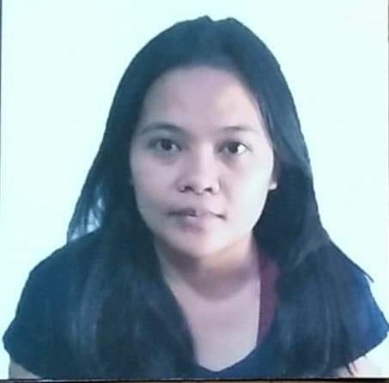

LOVELY SHYLENE U. MENDOZA
22 Semenary Rd. Bagbag Novaliches Quezon City
Mobile No. 09462461877
Email: Mendoza.12171415@gmail.com

CAREER OBJECTIVE:

As an experienced office worker abroad, I am seeking for other opportunity that might suitable for my knowledge or any position that can gain my ability.
EDUCATIONAL BACKGROUND:

SECONDARY ISMAEL MATHAY SR. HIGH SCHOOL
GSIS Village Project 8 Quezon City
S.Y. 2000-2004

ELEMENTARY PLACIDO DEL MUNDO ELEMENTARY SCHOOL
Talipapa Novaliches Quezon City
S.Y. 1994-2000

SKILLS:

- Computer Literate (MS Word, MS Excel)
- Mastery in Office Procedures (Handling Calls, Handling Mails, Filing etc.)
- Typing
- Good communication skills
- Event organizing

WORK EXPERIENCES:
Extreme Excite Parties and Entertainment Services
(Dubai, United Arab Emirates)
Sales
August 2016- August 2018

PERSONAL INFORMATION:

Nickname : Love
Birthday : Sept. 29, 1986
Age : 34 years old
Height : 4’11
Weight : 47 kg.
Nationality : Filipino
Civil Status : Single
Language : English, Filipino, Arabic
Religion : Roman Catholic
CHARACTER REFERENCES:

Ms. Jennylyn Vinluan Extreme Excite Parties and Entertainment Services
Owner
+971559269357

Mr. Ali Mohammad Abdulla United Investment Group
Owner/CEO
+971509028595

I hereby certified that the above information is true and correct to the best of my knowledge and belief.

Lovely Shylene U. Mendoza
Applicant

