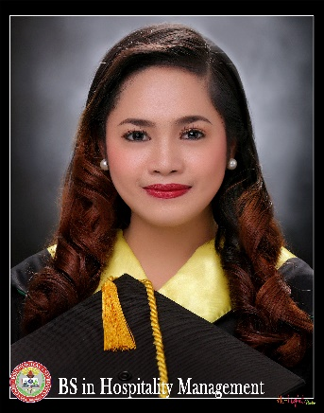

Shenae Mae C. Lorenzo
403-R Sanciangko Street Cebu City
09058044513
slorenzo2322@gmail.com

OBJECTIVES:
To work with professional staffs and gain more knowledge. Have an excellent communication skills, flexibility, have a record of integrity, accuracy and ability to work with all levels of people. To be part of a team where I encourage to learn new skills, perseverance and dedication to learn more things in life. To be independent. To be a strong asset to your company.

QUALIFICATIONS:

- Bachelor’s Degree
- Capacity to multi – task under pressure and can work any settings
- Proficient in Microsoft word, Access, Excel, Lutos Notes, Spreadsheet, Power point, and Open Office
- Strong leadership
- Resourceful, honest, extremely dedicated to work as a hard-working individual
- Reputation for excellence and high quality service to clients
- Highly motivated and focus
- Flexible and diligent worker
- Fast learner with minimal supervision
- Willing to train and can work in any shift

EDUCATIONAL BACKGROUND:

Tertiary: Cebu Technological University
Bachelor of Science in Hospitality Management
M.J Cuenco Avenue R. Palma Street, Cebu City, 6000 Cebu, Philippines
S.Y. (2015 - 2016)

Secondary: Abellana National School
Osmeña Blvd, Cebu City, Cebu, Philippines
S.Y. (2011 - 2012)

Elementary:
City Central School
Osmeña Blvd, Cebu City, 6000 Cebu, Philippines
S.Y. (2008- 2009)

WORK EXPERIENCE:

Dessert Factory Restaurant and Bakery
(Restaurant Supervisor) September 2019 - October 2020

Overseas Filipino Worker
(Operator in LED Company) June 2017 – August 2019
IBM (International Business Machine) Solutions Delivery, Inc.
(Facilities Helpdesk) March 16,2016 – June 2017
Diamond Suites and Residences
(Service Crew & Banquet Staff) October 2016 – March 2017

Harolds Hotel
(Banquet Staff) March 2015 – June 2015

La Fortuna Hotel
(Waiter) September 2015 - January 2016

Cosina Calza, Catering Services
(Waiter) January 2015 – August 2015

SKILLS:
- Computer literate
- A Sense of Humor
- Assertiveness
- Ability to work under pressure
- Resourcefulness
- Personal Skills
- Can work under pressure
WORKSHOP & SEMINARS ATTENDED:

Self-Empowerment Workshop (Jan. 5, 2015)

Getting Ready for the World of Work Workshop (Sept. 8, 2015)

Becoming Beautiful Inside and Out (Jan. 5, 2014)

Enhancing My Relations Skills (Sept. 18, 2014)

Waiters Relay Contest (Dec. 10-18, 2014)

Seminar on Front Office Procedure (Aug. 22, 2014)

CHARACTER REFERENCE:

Brgy. Captain Carlo V. Yap (Cel. # 09275836401)

