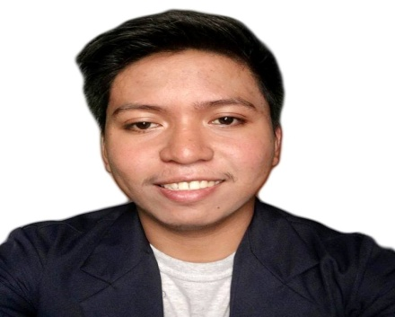
Name: MELVIN N. TAMAYO
Address: #260 Road 2 Matagdem, San Carlos City, Pangasinan
Contact No.: 09468107013
E-mail Add.: tamayomelvin21@yahoo.com

OBJECTIVE:

To secure a position that would best commensurate my qualifications and allow me to cultivate my potentials and make me an efficient and effective worker.

PERSONAL DATA:

Birth date : October 13, 1996
Age : 21
Sex : Male
Civil Status : Single
Citizenship : Filipino

EDUCATIONAL ATTAINMENT:

Tertiary : PANGASINAN STATE UNIVERSITY
Roxas Blvd., San Carlos City, Pangasinan
Course : Bachelor of Science in Business Administration
Major : Human Resource Development Management

Secondary : Doyong National High School
: Doyong, San Carlos City, Pangasinan

Primary : Doyong Elementary School
Doyong, San Carlos City, Pangasinan

SKILLS:
- Understand and know how to deal with people
- Good communication skills
- Interpersonal skills
- Organizing skills
- Knowledge of the capabilities and limitations of people
- Information gathering and reporting skills
- Highly organized and efficient

SEMINARS ATTENDED:

3rd AME Regional Marketing Management Education Convention
April 27, 2016
Mandapat Astrodome, San Carlos City, Pangasinan

1st Provincial and Regional Marketing Education for Students (PRIMES)
Pangasinan
November 16, 2017
Pangasinan State University, Lingayen, Pangasinan

Consumers Awareness Seminar
September 20, 2018
Audio Visual Bldg., Pangasinan State University, San Carlos Campus

Financial Literacy Coaching
November 7, 2018
Audio Visual Bldg., Pangasinan State University, San Carlos Campus

3rd Alchemize Leadership Training Seminar
December 7-9, 2018
Pangasinan State University, San Carlos Campus

TRAINING

Camp John Hay Leisure Incorporated (HR Department)
Camp John Hay, Baguio City, Benguet, Philippines
On the Job Training

CHARACTER REFERNCES:

ADONIS BAUTISTA, DBA
Research Instructor
@adonis.bautista.798
Pangasinan State University, San Carlos Campus

JEBRA MARIS B. SANOZA, MBA
Research Adviser
@jhebr
Pangasinan State University, San Carlos Campus

KIM ANGELA CRUZ
Instructor
@kimmiecruise
Pangasinan State University, San Carlos Campus

I hereby certify that the above information is true and correct to the best of my knowledge and belief.

MELVIN N. TAMAYO
Applicant

