
NOVELAS, SHAIRA MAY B.
Blk 13 lt 2 Kingdom One, Nagkaisang Nayon
Novaliches Quezon City
Contact No: 09351953076
Email: novelasshairamay25@gmail.com

OBJECTIVES

I am looking for a job where I could enhance my potential and ability, ready to learn new things where I could be more stable to apply my knowledge and skills and to give an opportunity to work productively and accurately in your company.

NATIONAL CERTIFICATE

Food and Beverages Services (NC II)
Certificate no. 16131402 000149
Valid until January 10, 2021

Front Office Services (NC II)
Certificate no. 15131402 029404
Valid until November 10, 2020

Bread and Pastry (NC II)
Certificate no. 15131402 031624
Valid until November 30, 2020

TRAINING AND SEMINARS

On Board Training
Apprenticeship by Experience (APEX) Program
Oceanlink Institute Inc. In partnership of 2GO Travel, St. Leo the Great
(MANILA-CEBU)-(CEBU-BUTUAN)
MARCH 4-7, 2016

Hotel in the Services Industry
Crown Legacy Hotel
Corner Montinola St Kisad rd St.Baguio City
December 06, 2014

Hotel Familiarization
National Teacher’s Camp, Baguio City December 05, 2014

NSTP Training
Sacrament Adventure Camp, Tanay Rizal
February 26-28, 2014

Food and Beverage Training Certificate
140 hours on the on job training at
Eurotel Cubao (EO1(Gen. Araneta Quezon City)
April 19-May 21 ,2016

Housekeeping Training Certificate
140 hours on the on job training at
Eurotel Cubao (EO1(Gen. Araneta Quezon City)
April 19-May 21,2016

Formal Accreditation Level 1
Formal Accreditation of two programs of BSHRM and BSBA Level1
Training as a kitchen staff
Bestlink College of The Philippines
December 1-5, 2015

WORK EXPERIENCED

The Coffeebean and Tea Leaf Philippines

Barista
Ayala Fairview Terraces
September 26, 2018 – November 3, 2019
Shift Supervisor Trainee
November 4, 2019- April 17, 2021

On call Food Attendant
Ella Mae’s Catering Services
San Jose Del Monte Bulacan
February 2016- April 2017

Home-based Online Encoder

Other Skills

· Basic baking
· Basic latter art
· Knowledge in Computer (Microsoft)

EDUCATIONAL BACKGROUND

Tertiary: Bestlink College of the Philippines
BRGY. Sta. Monica Quirino Highway, Quezon City
Course: Bachelor of Science in Hotel and Restaurant Management
 |  | 2013-2017
Secondary: |  | Rosales National High School
2009-2011 (Rosales, Pangasinan)
Vicente Madrigal National High School
 |  | 2011-2013 (Pantok, Binangonan Rizal)
Primary: |  | Bakit- Bakit Elementary School
2003-2009 (Rosales, Pangasinan)

PERSONAL INFORMATION

Age: |  | 24
Gender: |  | Female
Date of Birth: |  | November 5, 1996

Height: 5'4" Weight: 64kg
Place of Birth: Ramos Lying-in Bukidnon St. Bago Bantay, Quezon City
Religion: Born Again Christian

Civil Status: Single Citizenship: Filipino

Languages/Dialect: English, Tagalog, Ilocano & Pangasinense

‘’I hereby certify that the above information regarding myself is true and correct to the best of my knowledge and belief.’’
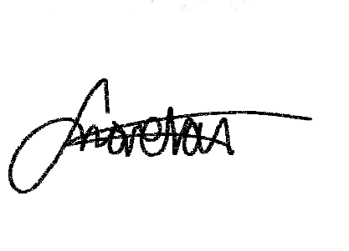

SHAIRA MAY B. NOVELAS

Applicant’s Signature

