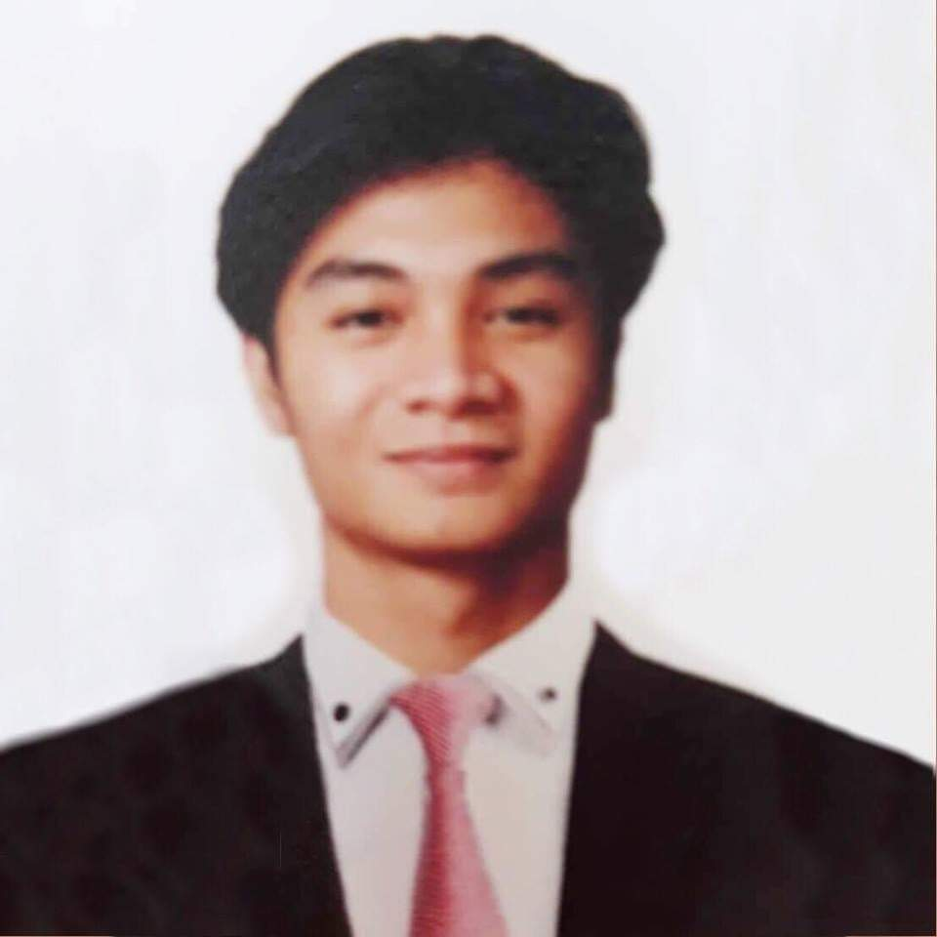
Carl Danielle D. Quitoriano
37# Sunflower St. Talon Village Kuatro, Las Piñas City
0938 177 6382 | carlquitoriano1997@gmail.com

Objective
To enhance my professional skills, capabilities and knowledge in an organization which recognizes the value of hard work and trust me with responsibilities and challenges to give the best quality service and demonstrate the competence that satisfies the interest of the company.
Summary
Industrious with an urge to work independently and well-focused on producing good quality food and providing excellent customer service.
Educational Attainment
Tertiary : Eulogio “Amang" Rodriquez Institute of Science and Technology – (2019)
Bachelor of Science in Hotel and Restaurant Management – Undergraduate
Congressional Rd. General Mariano Alvarez, Cavite
Vocational : AMA Campus – (2017 - 2018)
TVL - Home Economics
Regalado Avenue cor. Bristol Street Fairview, Quezon City
Secondary : Sta. Lucia High School – (2017)
J.P Rizal St. Barangay Sta. Lucia Novaliches, Quezon City
Primary : Talon Elementary School – (2004 - 2010)
San Antonio Valley Rd. Talon I, Las Piñas City
Achievements and Awards
Work Immersion
80 hours on-the-job training at Greenwich Pizza - SM Fairview
Knowledgeable in 5s Methodology such as; “sort, set in order, shine, standardized and sustain"
TESDA Qualified NC II (Certificate of Completion)
- Bread and Pastry Production
- Food and Beverages Services
- Cookery
Personal Data
Age : 23 years old
Birthplace : Quezon City
Civil Status : Single
Citizenship : Filipino
Height : 5’7 ft.
Weight : 57 kg
Skills
● Good work ethics | ● Critical Thinking
● Dedicated team player | ● Fast Learner
● Efficient customer service | ● Organized multi-tasking

Experience
Greenwich - SM Southmall LGF (October 2019 - February 2021)
Kitchen Crew (Pizza Maker) / Dining
Duties and Responsibilities:
Kitchen Crew
- Properly portioned on making the product according to the company standards measurement.
- Labeling and preparing all each essential product to practice this method (first-in, first-out) to avoid lapse product into waste and cut the toppings such as cheese, vegetables and meats.
- Following standard procedures for safe food preparation, assembly and presentation to ensure customer satisfaction.
- Helping other crew members to keep team workflow at efficient level when if its necessary.
- Oriented to performed various stations include dispatch and back-up.
- Perform closing duties including deep cleaning kitchen surfaces, storage and equipments.
- Always maintain cleanliness and well-organized to have an efficient working environment.
Dining
- Greet, serving and assisting the guest including their request such as brought to tables and fetched drink refills
- Bussing all table that have been used by guest and then sanitized.
- Always maintain cleanliness and well-organized working with satisfaction.
- Acknowledge the customers complaint and take action immediately to resolve the problem.
- Practicing safety preventive measures due to Covid-19 Safety Protocols.
References
Clyde C. Corsino - “Generation One Resources”
Team Leader
0919 834 3358
Mars C. Pableo - "Jollibee Foods Corps.”
Greenwich Senior Crew
0910 441 5756
Camille A. Garin - "Jollibee Foods Corps."
Greenwich Manager
0917 638 9558
.

I hereby certify that above information is true and correct to the best of my knowledge and belief.

Carl Danielle D. Quitoriano
Applicant

I would appreciate the opportunity to interview with the Company for any available position. Please find enclosed my resume for your review. I can reach at all times on the details provided above. I enthusiastically look forward to hearing from you soon.

Thank you for your time and kindly consideration.

Sincerely yours,

