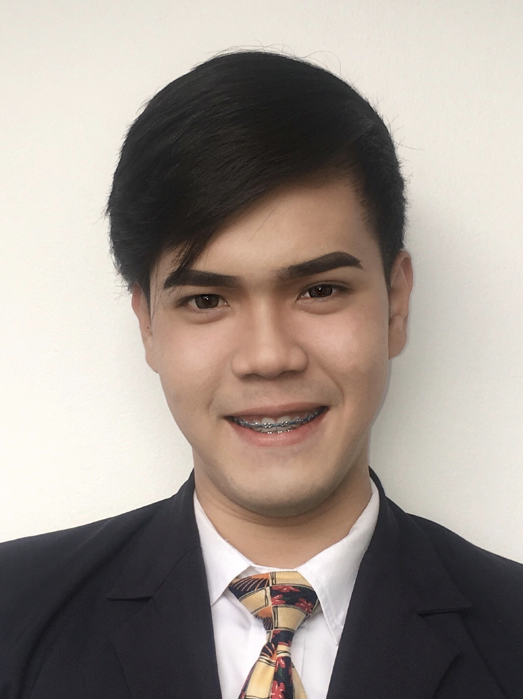
CLARENZ CEDEÑO SALONGA
B17 L30 Karlaville North Subd., Prenza II, Marilao, Bulacan
(63) 917-319-5226
clrnzzz@icloud.com

PROFESSIONAL SUMMARY:


A well-experienced and proficient Airline Passenger Service Supervisor willing to provide an exemplary customer-service. Knowledgeable on airport services and protocols significant on operations and serving the passengers the safety and security they deserve and looking forward to learn more with a prospect that offers growth and opportunity.
WORK EXPERIENCE | - MACROASIA AIRPORT SERVICES CORP.  Passenger Service Supervisor – PSD T2  Philippine Airlines  NAIA Terminal 2  October 2018 – Present  Passenger Service Agent 2 – PSD T2  August 2016 – October 2018  Passenger Service Agent 2 – PSD T3  Cebu Pacific Air, Inc.  Ninoy Aquino International Airport, Pasay  August 2014 – August 2016  - PHILIPPINE AIRLINES  Marketing Activations (Advertising & Promotions) Intern  3/F Mezz. PNB Financial Center, Diosdado Macapagal Blvd., CCP Complex, Pasay City  October 2013- February 2014
SEMINARS AND TRAININGS | - BASIC PASSENGER HANDLING TRAINING  - INTERMEDIATE PASSENGER HANDLING TRAINING  - DANGEROUS GOODS TRAINING  - AUSTRALIAN DOCUMENTATION TRAINING  - US DOCUMENTATION TRAINING  - CANADIAN DOCS TRAINING  - HUMAN FACTORS TRAINING  - IDEAL CUSTOMER JOURNEY WORKSHOP  - AMADEUS (GDS)
EDUCATIONAL ATTAINMENT | Tertiary:  Polytechnic University of the Philippines  Bachelor of Science in  Tourism Management  June 2010-May 2014  Secondary:  Malinta National High School  Malinta, Valenzuela City  High School Graduate  2006-2010
RELEVANT INFORMATION | - Has extensive background on procedures and operation in airport services  - Customer-service oriented and flexible in dealing with varying personalities and pressuring situations  - Excellent inter-personal skills and communicative, vital in the airline industry  - Fluent in Filipino and English  - 26 years old  - 5’6”  - 145 lbs
CHARACTER REFERENCE | - Emmynol Daza  Airport Services Manager- AOD T2  Philippine Airlines  +63 917 524 8598  - Ruscell Castro  Department Head – PSD T2  MacroAsia Airport Services Corp.  +63 917 529 9817  - Atlas Ablas  Area Manager  MacroAsia Airport Services Corp.  +63 917 655 7224
I hereby certify that the above information is true and correct to the best of my knowledge.

Clarenz C. Salonga
Applicant

