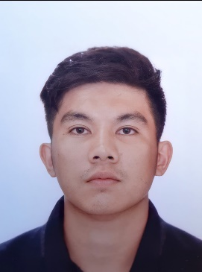
JOHN VENTURA DICKSEN
#1381 Kias Virac Baguio
+639-463-626379
bladyamel43@gmail.com

Qualification Summary

Advocate for customer’s rights, strive to understand a customers need and concern
Hard working patient and punctual
Organized and self-motivated
Ability to learn quickly and adopt to new environment easily
Proficient in MS office

Educational background

University of the Cordilleras
Bachelor of Science in Hotel and Restaurant Management
(2008-2011)

Work Experience

Holland America Line
PASSENGER CRUISESHIP
Galley Steward (2018-2020)

Caribou Coffee
Riyadh, Kingdom of Saudi Arabia (January 12, 2015- January 18, 2017)
Shift Supervisor in charge
Barista, Cashier

PIZZA HUT
Upper Session Baguio City (September 2013 – January 2015)
Team Member (Pizza and Dough Maker)

Yellow Cab
Lower Session Baguio City (April 2013- September 2013)
Kitchen Helper (Pizza and Dough Maker)

Max’s Restaurant
S.M Baguio City (October 2012- March 2013)
Kitchen Helper (Production, Assistant Cook)

City Travel Hotel
#15 kisad Road Baguio City (September 2011- July 2012)
Kitchen Helper (Assistant Cook)

Personal Information

Age: 29
Date of Birth: February 15, 1992
Civil Status: Married
Citizenship: Filipino
Height: 5’5’’
Weight: 70kg

Character Reference

Mr. Sampath De Silva
Deputy General Manager Caribou Coffee
Riyadh Saudi Arabia
Email : sampath@cariboucoffee.com.sa
+966-11-461-4948

Mark Magtangol Gimenez
Financial Adviser ( JP Morgan Chase)
Virac Itogon Benguet
+639169982330

Mr. Freddie Rivera Morales
Tarlac, Tarlac
+639153769734

