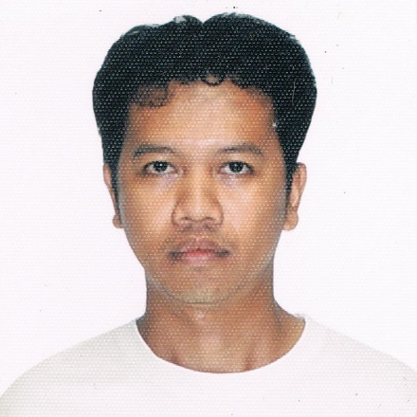
ERICKSON C. IBAY
54-A MELCHOR ST. LOYOLA HEIGHTS QUEZON CITY
09156037154/ 09186090273 / 433-8251
ibayerickson@gmail.com

Objectives:

To obtain a job that will use and enhance my skills and knowledge, as well as my communication, organizational and motivational skills.
Education:

Tertiary: Civil Engineering Technology 2000-2004
Technological University of the Philippines
Ayala Blvd., Ermita, Manila

Secondary: Quirino .High School 1996-2000
Molave St. Project. 3 Quezon City

Elementary: Quirino Elementary School 1990-1996
Anonas St. Project 2 Quezon City

Technical Proficiency:

- Basic Computer Knowledge
- Material Testing
- Basic Surveying
- Drawing and Drafting

Seminars Attended:

- September 14, 2000 IOP Plant Visitation for Civil Engineering
Subic Bay Freeport Zone
- February 6, 2001 Seminar Workshop on Advance Surveying Instrument
IRTC Auditorium TUP Manila
. February 6, 2001 CET/IOP seminar on Youth Values Information at the IRTC
Auditorium TUP Manila

- July 10-26, 2002 Basic Training Program, Concrete Materials Testing
IRTC, TUP Manila
- July 29-Aug. 9, 2006 Basic Training Program, Laboratory Soil Technology
        - at IRTC, TUP Manila
- August 12-23, 2002 Basic Asphalt Technology,IRTC, TUP Manila
- Dec. 2, 2003 toApril 30, 2004 SIT in City Engineer’s Office in Slum Clearance
Demolition Services City Hall, Manila

Work Experience:

Capital Garment Corporation
Presser
Ortigas Avenue ext. Taytay Rizal
May 14 to October 20, 2003

Shell Corporation
Forecourt Crew
October 19, 2004 to January 11, 2005
Rizal St. Lamuan , Marikina City

Jollibee Foods Corporation
Service Crew
February 2, 2006 to July 15, 2006

Philippine Geoanalytics Inc.
Laboratory Technician
February 17, 2007 to June 17, 2010

Phoenix Ready Mix Concrete Development and Construction Inc.
Site Engineer/ Coordinator
August 4, 2010 to October 31, 2016

Montalban Concrete and Asphalt Inc.
Site Engineer/ Coordinator
November 2, 2016 to April 10 2018

Quantum Materials and Inspection Laboratory Corporation
Laboratory Technician
June 18, 2018 to November 18, 2018

Personal Information:
:

Birthday: August 19, 1983
Birthplace: Quezon City
Age: 37 y/o
Gender: Male
Status: Single
Religion: Roman Catholic
Nationality: Filipino
Height: 5'6’’
Weight: 50 kg.

Character Reference:
:

Benjie Espiritu Head, Quality Control Montalban Concrete and Asphalt Inc.

09228144611 Rodriguez Rizal

Sherwin Lerum Site Engineer Montalban Concrete and Asphalt Inc.

09228229197 ` Rodriguez Rizal

Richard Macellones Laboratory in Charge Quantum Materials and Inspection Laboratory
Corporation

09101685013 Cubao, Quezon Cty

I hereby certify that the above information is true and correct to the best of my knowledge and belief.

Erickson C. Ibay

