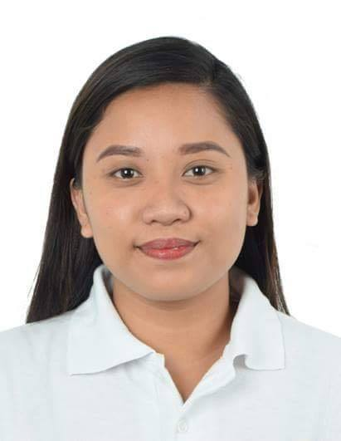
RESUME

Personal Information:

Name : Ma. Loreta R. Padilla
Address : Dancalan, Ilog Negros Occidental
Date of Birth : August 16, 1995
Age : 24 years old
Contact No. : 09155928319
Email : padillaloreta15@gmail.com

Education Background
College : University of Negros Occidental - Recoletos
Bachelor of Science in Social Work (2013-2017)
High School : Temple A.C.E Academy (2009-2013)
Elementary : Temple A.C.E Academy (2003-2009)

Character References:

ATTY. MERCEDES K. ALVAREZ
Former Congresswoman
6th District, Negros Occidental
09184125739

HON. LEO TREMUCHA
SB Member
Ilog, Negros Occidental
09503519085

HON. REY CORDOVA
SB Member
Ilog, Negros Occidental
09394492875

Seminars and Trainings:

- SOCIAL WELFARE AND DEVELOPMENT (SWAD OFFICE) REGION 6
PAC Building, Aguinaldo St. Bacolod City
June - October 2015
Social Work Intern

- HOME OF HOPE INC.
Brgy. Handumanan Bacolod City
November - March 2016
Social Work Intern
- DEPARTMENT OF SOCIAL SERVICES AND DEVELOPMENT
June - October 2016
3rd Floor, New Government Center
Circumferential Road, Bacolod City
Social Work Intern

FIRST STEP TO LEADERSHIP SEMINAR
October 3, 2016
UNO-R Gym, UNO-Recoletos
Bacolod City

LEGACY FORUM (STUDENT EMPOWERMENT: CHANGE IS NOW)
September 6-7, 2016
UNO-R President’s Hall, UNO-Recoletos
Bacolod City

SEMINARS ON CURRENT TRENDS IN SOCIAL WORK
December 2015 - March 2016
UNO-Recoletos
Bacolod City
- Disaster Risk Reduction Management (DSSD)
- Overseas Employment (OWWA)
- Philippine Employment and Services Office
- Climate Change
- Sustainable Development (DENR)
- Sustainable Livelihood Program
- Technology Revolutionizing the Field of Social Work

SEMINAR ON GENDER SENSITIVITY
November 26, 2014
Little Theater, UNO-Recoletos
Bacolod City

SEMINAR ON SELF-AWARENESS
November 19, 2014
High School ACC Hall, UNO-Recoletos
Bacolod City

SEMINAR ON THE FIELDS OF SOCIAL WORK
- CHILD WELFARE
- MEDICAL SOCIAL WORK
August 2014
High School ACC Hall, UNO-Recoletos
Bacolod City

Work Experiences:

- DEPARTMENT OF SOCIAL WELFARE AND DEVELOPMENT
Pantawid Pamilyang Pilipino Program
October 2017- December- 2017
Community Development Assistant

- Bacolod Boy’s Home Foundation Inc.
Orphaned, Neglected and Abandoned Children
April 13, 2018 – May 30, 2019
Residential Social Worker

- DEPARTMENT OF SOCIAL WELFARE AND DEVELOPMENT,
(SWAD OFFICE) REGION 6
Crisis Intervention Unit
Women Center, Bacolod City
September 23, 2019 – May 30, 2020
Social Welfare Officer II

