NONIELYN M. MACATANGAY RN
Tambobong Street, Batangas City Phils.
Mobile No.: 09983821212
Email: nonielynmacatangay@gmail.com
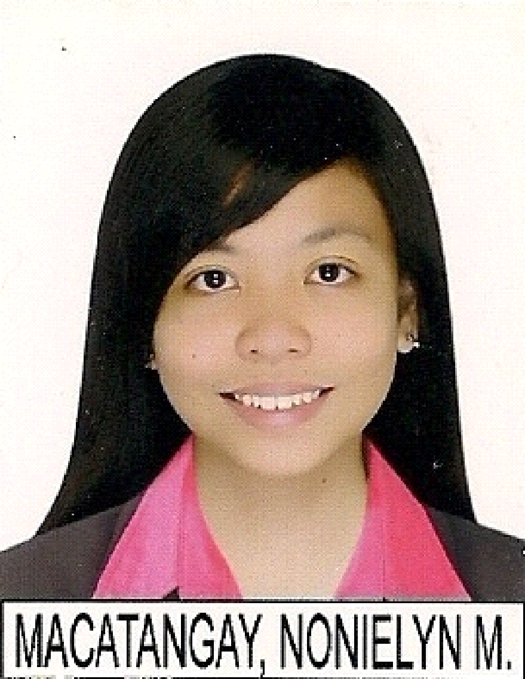
Registered Nurse in Philippines
Registered Advanced Cardiovascular Life Support Provider
Registered Basic Life Support Provider
Senior Caregiver/Team Leader/Supervisor in London U.K. 2010-2012

PERSONAL INFORMATION:

Surname: Macatangay
Given Name: Nonielyn
Middle Name: Mendoza
Permanent Address: Tambobon Street Batangas
City Philippines 4202
Date of Birth: September 5, 1985
Age 35 years old
Place of Birth: Batangas City
Nationality: Filipino
Gender: Female
Marital Status: Single
Height: 5’2
Weight: 115 lbs

ACHIEVEMENTS
Postgraduate Diploma in Healthcare Management- London, U.K.
Nursing Licensure Board Examination- Philippines

EXPERIENCES

Family Private Nurse
Leonida Mendoza
Employer
July 18, 2018 up to December 28, 2020

EXLSERVICE PHILIPPINES,INC.
Disability Nurse Clinician
April 16, 2018 to June 30, 2018
Pasay, Mall of Asia Complex Manila,Philippines

United Doctors of Saint Camillus Hospital
HeadNurse ( ICU Department ) October 2016 to November 2017
Intensive Care Unit Staff Nurse August 2013 to October 2016
8hours per day, 5 days a week
United Doctors of St. Camillus De Lellis Hospital
Diversion Road, Bolbok Batangas City, Philippines

Children’s Clinic
Nurse Reliever
June 2, 2012-September 2, 2012
January 2, 2013-March 2, 2013

Eastgate House is a European Residential Care Home with 41 Geriatric Residents
London, U.K
Senior Care Assistant/ Team Leader / Supervisor
October 2010- April 2012
20 hours per week during College Days / Full time during Holidays

Batangas Healthcare Jesus of Nazareth Hospital Phils.
Position: Nurse Trainee/Nurse Reliever
July 16, 2009 – August 9, 2010
Neonatal Intensive Care Unit
Pediatric Ward
Operating Room
Intensive Care Unit

Batangas City Maternity House and Puericulture Center Phils.
Nurse Trainee
March 2, 2009-July 10, 2009

0B-Gyne Clinic
Medical Secretary Assistant
Batangas Philippines
September 6, 2007-February 27, 2009

SEMINAR and TRAINING ATTENDED
( In UNITED KINGDOM)
Deaf Awareness and NHS Hearing Aids
West Norfolk Deaf Association
October 27, 2011

Manual Handling
EASTGATE, 2011
Diabetes Meeting and Training
EASTGATE
Trainer: Ms. ANITA MURPHY
February 21, 2011

Emergency First Aid at Work
EASTGATE
Trainer: Mr. CLINT WALKER
December 9, 2010

Safeguarding Vulnerable Adults in a Care Home
Food Hygiene in a Care Home
Care Planning
Managing Challenging Behaviour
Fire Safety: Hazards and Prevention
EASTGATE
Trainer: Ms. ANGELA DACK
October 2010 valid until OCTOBER 2011

(In PHILIPPINES):
Advanced Cardiovascular Life Support
Basic Life Support
American Heart Association
Batangas City
July 2017

Novel Tools for Cardiovascular Risk Assessment
Philippine Heart Center, Quezon City
June 19, 2017

Patient Safety in Clinical Perspective
Teacher’s Conference Batangas City
November 18, 2016

Institute for Neurosciences Section of Adult Neurology
Ponte Fino Hotel Batangas City
July 16, 2016
Guide to Comprehensive Dengue Nursing Management
United Doctors of Saint Camillus De Lellis Hospital
Batangas City, Philippines
October 20, 2015

Work Ethics
United Doctors of Saint Camillus De Lellis Hospital
Batangas City, Philippines
September 30, 2015

Adult CPR, Child CPR, Infant CPR, Mag Mask Ventillation, Automated External Defibrillator Operation, Adult and Infant Choking Program
American Heart Association
July 13, 2015-07

BLS, ACLS Surveys, Airway Management, CPR and AED Skills, Megacode and Team Resuscitation Concept, Acute Coronary Syndromes, Acute Ischemic Stroke Program
American Heart Association
July 13-14, 2015

Nurses Initiatives On High Risk Pregnancies
United Doctors of Saint Camillus De Lellis Hospital
Batangas City, Philippines
June 15, 2015

Effective Nursing Assessment and Management of Pneumonia
United Doctors of Saint Camillus De Lellis Hospital
Batangas City, Philippines
February, 2015

Nursing Assessment and Continuum Of Care Of A Stroke Patient
United doctors of Saint Camillus De Lellis Hospital
Batangas City, Philippines
April 25, 2014
ALPS MEDICAL MISSION 2014
Dagatan National High School
Dagatan, Taysan Batangas
February 23, 2014

EDUCATIONAL BACKGROUND
Postgraduate Diploma in Healthcare Management- London, U.K.

Tertiary University of Batangas
Bachelor of Science in Nursing
Batangas City, Philippines
2002-2007

KNOWLEDGE, SKILLS and QUALIFICATIONS

Easy to adapt any kind of job, with less supervision.
Adaptable, analytic, fast-learner, hardworking & trustworthy
Can communicate well focusing to details of conversation.
Ability to handle people and dealing with others.
Capable of working under time pressure.
Proficient in computer.
Respectful, caring, possesses cultural awareness and sensitivity.
Demonstrate sound work ethics.

LANGUAGES
Language Level
English Average
Filipino Fluent

International English Language Test
(General Training Test) – Tagaytay, Philippines
January 21, 23, 2021

Listening – 7
Reading – 6
Writing – 6
Speaking - 6
Overall – 6.5

CHARACTER PREFERENCES

- Mrs. Leonida N. Mendoza
Employer
Santa Rita Karsada Batangas City
Telephone Number – 09662012811
Email address – mleonida799@gmail.com

- Mr. Roland Magmanlac RN, MAN
Chief Nurse, United Doctors of Saint Camillus De Lellis Hospital
Batangas City
Telephone Number – 043-723-740-3087

Nonielyn Macatangay RN
Applicant’s signature

