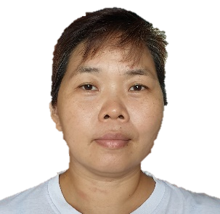
Jennifer Yee

Undan

 | 09612746247 |  | ABOUT ME
 | Jennifer_undan@yahoo.com
 | Purok 2, Poblacion, Banaybanay, Davao Oriental, 8208 |  | Reliable team member accustomed to taking on challenging tasks, and trained in communication skills as well as managing abilities. | Motivated to continue learning and growing as a well-trained professional dedicated to business success. Hardworking employee focused on completing work quickly to consistently exceed targets.
Skills  - Quality control analysis  - Machinery operations  - Product Assembly  - Parts inspection  - Costumer Relations  - Multitasking  - Motivation  - Hospitality  Education  Bachelor of Science – Pharmacy  San Pedro College, Davao |  |  | Experience  Factory Worker Sept 2018 – Apr 2019  Inspectra, Malta, Europe  - Followed exact job specifications to produce products of consistent quality and precisely lined up with costumer expectations.  Elderly Caregiver Jun 2010 – Mar 2016  Ahuzat Beit Hakerem Senior Residence, Jerusalem, Israel  - Maintained case notes to document resident progress and condition.  - Provided dignified care to residence in assisted living and memory care communities, including those with stages of dementia and Alzheimer’s disease.  - Encouraged social interaction of clients and participated in activities  Factory Worker Jun 2007 – Jun 2008  Promos, Taiwan  - Operated manufacturing equipment and used hand tools to complete production orders as well as checking product materials or final work for compliance with quality standards.  Accounting Clerk May 2005- Mar 2006  BI Garments Inc. Brunei  - Coded transactions according to the internal company system to avoid errors.  - Processed daily invoices and payments to keep accounting records current.

