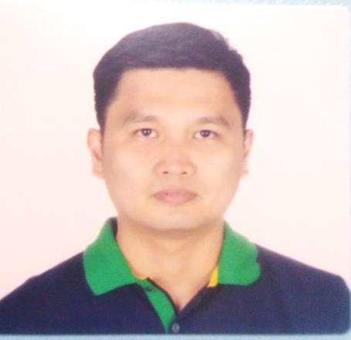
ERROL JARAVATA PALAROAN
0916 5503046 / ejp_tat@yahoo.com / 87 Santiago, Bauang, La Union

Detail-oriented gaming table supervisor with 2+ years’ experience, improving the effectiveness of daily operation at a prestige resort and casino.Loyal employee for 10+ years at the company. Enthusiastic individual eager to contribute to team success through handwork. Clear understanding of task and trainings, motivated to learn, grow, excel and contribute to the success of the company I’ll be working with.

QUALIFICATIONS
- Knowledge in Microsoft Word Office
- Flexible and quick learner
- Strong organizational and communication skills.
- Have strong focus on accuracy, high integrity, and reliability of work.
- Dedicated, self-motivated, organized, and able to work in a deadline-driven environment.
- Problem solving, team player, attention to details, giving feedback and patience.
WORK HISTORY

Gaming Supervisor (10.2017 to 12.2020)
Thunderbird Resorts and Casino
Poro Point, City of San Fernando, La Union
- Work flexible hours; night, weekend, and holiday shifts.
- Devoted special emphasis to punctuality and worked to maintain outstanding attendance record, consistently arriving to work ready to start immediately.
- Increased customer satisfaction by resolving game issues.
- Delivered exceptional level of service to each customer by listening to concerns and answering questions.
- Developed and maintained courteous and effective working relationships.
- Monitor game operations to ensure that house rules are followed.
- Support personnel of the Pit Managers to ensure the smooth flow of the operation.
Dealer II (06.2013)
Thunderbird Resorts and Casino
Poro Point, City of San Fernando, La Union
- Upgraded responsibilities of Dealer III with additional table games to conduct.
- Also, as an dealer inspector.
Dealer III (04.2010)
Thunderbird Resorts and Casino
Poro Point, City of San Fernando, La Union
- Exchange paper currency for playing chips or coin money.
- Pay winnings or collect losing bets as established by the rules and procedures of a specific game.
- Deal cards to house hands and compare these with players’ hands to determine winners.
- Conduct gambling limited games following all applicable rules and regulations.

Production Supervisor (07.2008 to 09.2008)
Bestlink Resources Inc.
Assigned at Universal Robina Corporation
Cavite Plant, FCIE, Langkaan, Dasmarinas, Cavite
• Check production output according to specifications.
• Enforce strict safety guidelines and company standards.
• Submit Reports on performance and progress.
• Maintained clean and well-organized production areas to avoid violations and work delays.
• Prepared and monitored production machinery to maintain optimal production levels and
Consistently achieve daily targets.

EDUCATION

Bachelor of Science in Electrical Engineering (03.2008)
Don Mariano Marcos Memorial State University
Mid La Union Campus, City of San Fernando, La Union

