Objective  To establish a stable management unit in terms of administration, finance, marketing, project operation unit and to provide quality products and services thus supplying all materials intended for Industrial and Commercial side of marketing together with quality services to our customer.  Skills  - Techinically equipped in terms of coatings & technology  - Computer literate  - Driving | Experience  VP – FINANCE / MARKETING  SMARTCOAT CONSTRUCTION & SERVICES INC.  (FAMILY BUSINESS)  MANDALUYONG CITY  JAN. 9, 2015 – UP TO PRESENT  SCOPE OF WORKS:  MANAGED ADMINISTRATION, FINANCE, TO INCLUDE COLLECTIONS, BILLING WITH OUR CUSTOMERS, MONITOR STOCKS (FIRST IN , FIRST OUT), ASSIST IN OPERATION SET UP ON SERVICES LIKE IN PAINTING , FLOOR COATINGS, WATERPROOFING, AND MARKETING.  specialize in floor coatings and waterproofing.  gENERAL CONSTRUCTION WORKS AND OTHER RELATED SERVICES LIKE AIRCON CLEANING , INSTALLATION, aLUMINUM AND gLASS INSTALLATION AND OTHERS.  general manager  rtsquare trading & general Painting works (owned business)  mandaluyong city  july 2013 – Dec. 2017  scope of works:  MANAGED ADMINISTRATION, FINANCE, TO INCLUDE COLLECTIONS, BILLING WITH OUR CUSTOMERS, MONITOR STOCKS (FIRST IN , FIRST OUT), ASSIST IN OPERATION SET UP ON SERVICES LIKE IN PAINTING , FLOOR COATINGS, WATERPROOFING, AND MARKETING.  specialize in floor coatings and waterproofing.  SENIOR SALES ENGINEER  PROTECTIVE COATINGS – HEMPEL DIVISION  INKOTE PHILIPPINES INC.  MARCH 2010 – JUNE 2013  scope of work:  responsible in all key accounts like petron refinery, shell, chevron and other oil related companies.  annual/ monthly sales forecast  monitor and develop technical sales for protective industry like heavy industries, power plant, mining, oil & gas, major contractors and fabricators like eei , eei marine, etc…  responsible in estimates for project requirements  secure labor & materials projects , thus conduct meeting with possible applicator/contractors.  quarterly/ annual product forecast  COLLECTION  DEVELOP NEW ACCOUNTS  EXPERIENCE  sales engineer  protective coatings – international paint division  megapaint corporation  brgy. mariana new manila , quezon city  Dec. 2005– feb. 2010  scope of work:  responsible in all key accounts like petron refinery, shell, chevron and other oil related companies.  annual/ monthly sales forecast  monitor and develop technical sales for protective industry like heavy industries like power plant, mining, oil & gas, major contractors and fabricators like eei , eei marine, etc… in the said field.  quarterly/ annual product forecast  COLLECTION  DEVELOP NEW ACCOUNTS  key account executive  industrial division  pioneer specialty building inc.  balete drive, new manila quezon city  oct. 2002 – nov. 2005  scope of work:  monitor existing accounts thus develop new accounts  closely monitor key/major account like San Miguel, lpg  monthly forecast as well as annual Sales forecast  resposible in collection  material forecast  sales engineer  ici- autocolor division  material resources inc.  edza boni, mandaluyong city  feb. 2001 – june 2002  scope of work:  promotes ici autocolor to all automotive industry to include OEM or original equipment materials.  closely monitor existing key accounts.  provide mixing machine to some major customer.  ensures availability of stocks.  annual/monthly sales forecast  annual/monthly materials forecast  coating specialist  ameron protective coatings  dutch boy phils. inc.  fcie, dasmarinas cavite  april 1995 – jan. 2001  scope of work:  monitor existing accounts thus develop new accounts  responsible in bataan area  monthly forecast as well as annual forecast  resposible in collection  material forecast  chemical specialist  chemical / industrial division  industrial chemicals phils.inc. / CHESTERTON  salcedo st. makati city  april 1993 – feb. 1995  scope of work:  Secure monthly sales target  promote chemicals, lubricants and other coil cleaner (industrial industry)  develop new accounts  Education  BACHELOR OF SCIENCE IN CHEMISTRY  ADAMSON UNIVERSITY  san marcelino, manila  YEAR GRADUATED : MARCH 1994  highschool  san felipe neri parochial school  mandaluyong city  year graduated: march 1989  elementary  san felipe neri parochial school  mandaluyong city  year graduated: march 1985  SPECIAL AWARDS  ACCOUNT DEVELOPMENT AWARDEE  DUTCH BOY PHILIPPINES INC.  NATIONAL SALES CONFERENCE  YEAR 2000  - COLLECTION AWARDEE (2ND PLACE)  DUTCH BOY PHILIPPINES INC.  NATIONAL SALES CONFERENCE  YEAR 2000  - TOP GROSSER AWARDEE  PACIFIC INSURANCE COMPANY  YEAR 1999  SEMINARS / TRAINING ATTENDED :  - TRAINING IN ONSHORE/ OFFSHORE COATINGS SPECIFICATION HELD BY ASIA PACIFIC REGION HEAD  INTERNATIONAL PAINT –UNITED KINGDOM  VENUE : MARRIOT HOTEL, SINGAPORE  YEAR : APRIL 2008  - PAINT TECHNOLOGY  INKOTE PHILS. INC.  VENUE: CHEVRON PHILS., BATANGAS CITY  YEAR 2011  - SSPC – VARIOUS SEMINARS  PERSONAL INFORMATION  - COMPLETE NAME : REMEDIOS HIDALGO – PARADO  - Address : 100 A. Bonifacio St. Mandaluyong City  - Blk 8 lot 9 & 10 Cedar St. Woodlandhills Subd. Bancal Carmona Cavite  - Email Add : remyparado@gmail.com  - Contact nos. : 09212567799  - Gender : Female  - Birthday : May 12, 1972  - Birthplace : Sta. Maria Bulacan  - Age : 48 years old  - Name of Husband : TONY REY LABAOIG PARADO  - Age : 49 years old  - Birthday : May 05, 1971  - Occupation : President  - SMARTCOAT CONSTRUCTION & SERVICES INC.  - Children : TONY ANDRÉ SEBASTIAN H. PARADO  - 18 years old  - Aug. 02, 2002  - College : 2nd year  - Physical Theraphy  - LaSalle -HSI, Dasma Cavite  - : TONY RUSSELL H. PARADO  - 17 years old  - Nov. 06, 2003  - Grader : grade 12  - Colegio San Agustin- Binan  - : TONY ISAAC H. PARADO  - 15 years old  - June 10, 2005  - Grader: grade 11  - Iacademy Arts School – Mkt.  - : TALHIA CRISTINA REIGN H. PARADO  - : 4 years old  - Aug. 26, 2016  I CERTFY THAT ABOVE MENTIONED INFORMATION ARE TRUE AND CORRECT.  SGD. 1/25/2021  REMEDIOS HIDALGO – PARADO  NICKNAME : REMY  09212567799  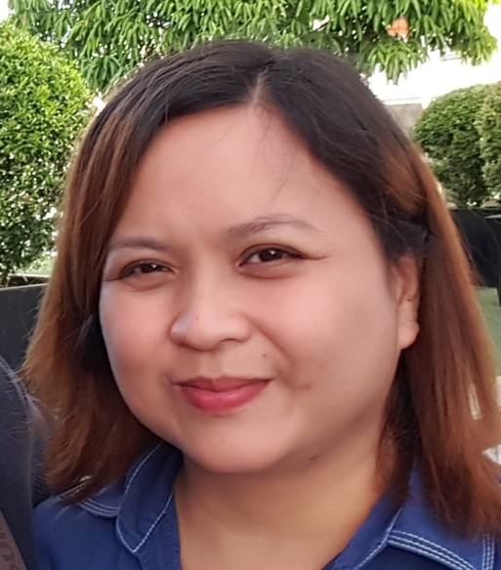
  remedios hidalgo - parado
  Contact no. 09985631481/09178704363 * add: blk 8 lot 9 & 10 cedar St. woodlandhills subd. bancal carmona cavite & 100 a. bonifacio st. mand. city

