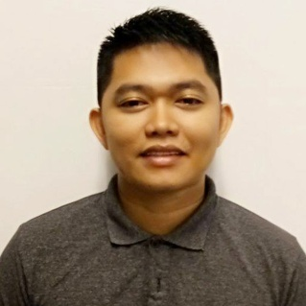
Gilbert H. Caalam
Mapagbigay Street, Barangay Pinyahan Quezon City
Contact #:09612812517
E-mail Address: bertskiez07@yahoo.com

Objective
To be able part of the company/organization where I could use and enhance my knowledge and to gain some experience for successful future achievement.

Work Experience
San Beda College
Mendiola, Manila
(IT STAFF)
(July 16, 2013-December 18, 2013)

Columbia Technologies, Inc.
J. Nakpil Street Malate, Manila
(IT Trainer)
(February 17, 2014-May 17, 2014)

Mother Spice Food Corporation
(IT STAFF
(July 21, 2014-December 31,2015)

Orange Power Network Inc.
South AA Barangay Paligsahan Quezon City
(IT STAFF)
(January1, 2016-Present)-Continues Contract
Training/Seminar
Social Security System
East ave. Diliman Quezon City
(On the job Training)
November 22, 2103- February 28, 2013
Professional Skills
- Knowledgeable in Microsoft Office such as; Microsoft Office Power point, Microsoft Office excel, Microsoft Office Word
- Configuring Wireless Router
- Hardware( repair laptop,printer,computer desktop)
- Troubleshooting(Desktop,Laptop,Printer and Telephone)
- Installation SERVER r2 2008,FILE SERVER,FTP SERVER and Set-up Network
- Basic Photoshop
- CCTV Installation
- POS(Point of Sale)Food and Retail
Personal Information

Nickname : “Bert” Height : 5’2
Gender : Male Weight : 68 kls.
Age : 28 Religions : Catholic
Date of Birth : September 28, 1992 Mother : Ester H. Caalam
Place of Birth : San Fernando Masbate Occupation : House Wife
Civil Status : Single Father : Mateo E. Caalam
Citizenship : Filipino Occupation : Construction Worker
Guardian : Ester H. Caalam
Educational Background

Tertiary : Sorsogon State College Bulan Campus (SSC-BC) 2013-2009
(Bachelor of Science Information Technology)
Secondary : Andres Clemente Jr. High School (ACJHS) 2009-2005
San Fernando Masbate
Elementary : West Elementary School 2005-1999
San Fernando Masbate

Self Actuation
- Willing to undergo over time.
- Capable to do multi-tasking.
- Job fearing

Affiliation
- Infomantech.com Organization
- Student 4Christ Organization

References
Rose E. Ferreras
Campus Administrator Jeremy Joseph Balgos
Head IT Manager
Contact #: 09478908449 Contact #: 09175210277

Zozimo C. Borlaza Msg. Ronnie T. Laceda PN(M)
Social Security System Mac Diliman Register NCO,HSETC,AFPHSC
Team Head V. Luna Avenue Quezon City
E-mail: borlaza@sss.gov.ph Contact#09230851023

I hereby certify that the above information is true and correct to the best of my knowledge and belief.
Gilbert H. Caalam Applicant

