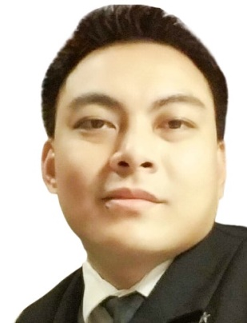

JEROME A. VIADO

CONTACT INFORMATION
Email: ja_viado@yahoo.com
Phone: +639283165079
Address: 177 Rizal St. Pob. 1 Infanta, Quezon Province

SKILLS
Problem Solving
Adaptability
Time Management
Handling Pressure
Multitasking
Team Work
Interpersonal Communication

EDUCATION
San Sebastian College-Recoletos
Quiapo, Manila
B.S. Hotel and Restaurant Management
2002 – 2006
Arellano University
Sampaloc, Manila
B.S. Hotel and Restaurant Management
2001 – 2002
Mount Carmel School of Infanta
Infanta, Quezon Province
High School 1997 – 2001
Infanta Central Elementary School
Infanta, Quezon Province
Elementary 1991 - 1997

JOB EXPERIENCE

Celebrity Cruises
Miami, Florida
Waiter - August 2014 – Present
- Set up tables, explain menus, take orders, serves food and beverages, and cleans tables in their assigned areas. Must know the menu items and ingredients to be able to promote the items being served and answer guests’ questions. Also is fully responsible for ensuring the satisfaction of guests in their stations. And coordinates service with his/her Assistant Waiter according to service procedures.

Assistant Waiter September 2011 – May 2014
- Works with other Waiters to serve meals and take care of diners. Also in charge to set up tables, take orders, serve food and drinks, and clean tables. Must also become familiar with menu descriptions and wine lists, and work in various food and beverage areas.

Snack Attendant Casual Dining July 2010 –June 2011
- Work in the buffet area and provide courteous, friendly, and professional food and beverage (F&B) services to guests. Interact with guests and fellow shipboard employees, promptly replenishing the food and beverages in the buffet line. Follows company standards, international health and safety guidelines, and environmental and workplace safety policies and procedures and may be required to perform all functions in various onboard food and beverage service venues.

Galley Steward May 2008 – January 2010
- In charge of cleaning all food preparation work areas, galleys, dish/pot washers, and related onboard venues. Observes proper waste handling and perform all tasks according to the Save the Waves program and USPH regulations.

New Coast Hotel Manila (formerly New World Manila Bay Hotel and Hyatt Regency Hotel)
Malate, Manila
Waiter – Market Café - June 2007 to February 2008
-responsible for taking orders and serving food and beverages to guests and is responsible for checking on customers to ensure that they are enjoying their meals and take action to correct any problems

Diamond Hotel Philippines
Malate, Manila
Waiter - Palm Court Café – September 2006 to February 2007
- Provides excellent customer services from greeting customers to presenting menus and serving food and drinks. Also, knows how to make suggestions based on the customer preferences

