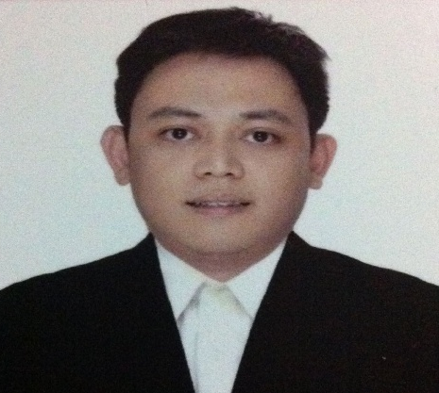
MARK PAUL GOMEZ VIRAY
Unit 2M #7 Katarungan Street Mandaluyong City
NCR, Philippines
Contact No# +63977 2773958
Civil Service Eligibility# 08- 147017
Email Address: markpaulviray@yahoo.com

WORK EXPERIENCE

Position Dealer June 15, 2018 – present
Company Norwegian Cruise Line
- Vacation Hero Awardee of the Month (November 2019)
- Department Awardee
- Top Comment Card Earner (Nov & Dec 2019)
- Guest Comments/Satisfaction Rating card

Position Pit Supervisor January 2017- Feb 2018
Company Tiger Resort, Leisure and Entertainment Inc.
Okada Manila Hotel & Casino
- In Charge of a Pit consisting minimum of 4 table games
    - Open and Closes table upon Operations Manager discretion
    - Maintain and Balance Cash Chip Float
    - Attend to customer needs
    - Supervise Dealer according to the needs of the company
    - Can handle games like American Roulette, Black Jack, Pontoon, Baccarat Super Six, Commission Baccarat, Stud Poker, Paigaw Poker, Texas Holdem Poker

Position Asst. Site Manager/ Safety Officer April 2013- Dec 2014
Company Xiphoid Inc. (Contractor)
- In Charge of daily Business Operations
- Prepares daily work permits
- Performs daily toolbox meeting
- Prepares and Submit bid forms and Scope of works
- Purchaser

Position Customer Service Representative May 04, 2014- June 2014
Company SPI Global Solutions Inc.
- Inbound Customer Service Representative
- Handled DISH network campaign

Position Professor June-October 2008/ March 2013
Company Jose Rizal University (part time)
- Taught different programs in Hotel and Restaurant Management course
    - Baking and Cake Decorating
    - Bar Operation and Management (Mixology)
    - Food and Beverage Service and Techniques (Waiter Service)
    - Housekeeping Management (Room Attendant)
    - Asian Cuisine (Asst. Chef)

Position Dealer May 07, 2005- Feb.25, 2013
Vault Clerk March 24, 2004- May 6, 2005
Company Philippine Amusement and Gaming Corporation (PAGCOR)
- In charge of the Table Capital worth 700,000 up to 15 Million pesos
- In charge of checking and monitoring the players gaming profile.
- Attending the needs of the players/customers/guest.

Position Call Center Agent August 18, 2003- March 13, 2004
Company Software Ventures Inc.
- Handled Verizon (online directory) campaign

Position Housekeeping Attendant October, 2002- April 2003
Company Prime Manpower Services Inc.
Makati Shangri- La Hotel Manila
- Cleaning the guest rooms at assigned area/floor
- In charge of securing, refilling the room amenities

EDUCATIONAL BACKGROUND

Post Graduate
Jose Rizal University
Master’s in Public Administration
Class of 2013 (undergraduate)
Tertiary
Polytechnic University of the Philippines
Bachelor in Hotel and Restaurant Management
1998-2002
- Class Representative
TRAININGS ATTENDED

- Basic Occupational Safety and Health (BOSH)
Bataan Peninsula State University
September 22-26, 2014
- Safety Officer Training Course

PERSONAL BACKGROUND

Nickname Mark
Birth Date August 12, 1981
Birthplace Manila
Height 5'8"
Weight 195 lbs

