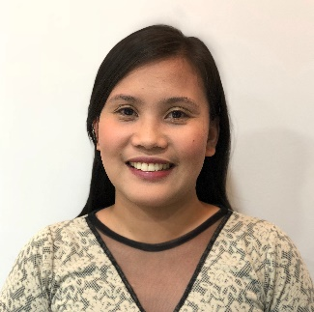
RHEA BALIGAD UDAUNDO
Licensed Customs Broker
Contact No. 09178609505

OBJECTIVE : To be able to seek immigration/residence visa and therefore live in a country
where there is full of possibilities and good opportunities.
PERSONAL DATA
GENDER : Female
CIVIL STATUS : Married
AGE : 32 years old
BIRTHDAY : October 14, 1988
BIRTHPLACE : Sand Andres, Sanchez Mira, Cagayan, Philippines
CITIZENSHIP : Filipino
RELIGION : Christian
ADDRESS : Prenza 1, Marilao , Bulacan

EDUCATIONAL BACKGROUND
TERTIARY : International School of Asia and the Pacific
2005-2009
SECONDARY : Namuac Academy
2001-2005
ELEMENTARY : Namuac-San Andres Elementary School
1996-2001

WORK EXPERIENCES
2010-2021 : Asia Cargo Container Line, Inc.
Import Documentation Staff (3 mos)
Customer Service (3mos)
Sales Representative/Account Executive (up to present)
JOB DESCRIPTION: Handle clients for their import and export shipments
Prepare rates and proposal
Coordinate and communicate to freight forwarding and shipping lines companies
Correspondence to network of agents worldwide
Assist billing department for clients’ statement of account
Assist collection department for clients outstanding
SKILLS: Good communication
Able to follow instructions excellently
Perform job efficiently and effectively
Flexible and willing to learn
Can work without supervision
CHARACTER REFERENCES
Sunshine Macapaar
09175536365
Luvin Dela Cruz
09178027601

