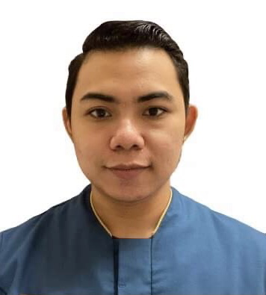
MARY ROSE A. ECALDRE
R. Bras Da Rosa Edf. Ngan Seng Kok, Fl18 Flat N, Macau
Contact No.: +853 62265388
E-Mail Address: mraecaldre@yahoo.com

HIGHLIGHTS
• Graduate of Advance Diploma in Computer Programming.
• Computer Literate in Microsoft Office applications such as Word, Excel, and PowerPoint.
• Install, diagnose, repair and maintain information technology infrastructure including but not limited to printers, copiers, scanners.
• Good in English communication and can speak basic Cantonese language.
• Works well under pressure. Highly responsible and reliable.
• Excellent multi-tasking; neat and clean appearance; learns quickly.
- Competent and dependable housekeeper with experience in five-star hotel. Valued for impeccable standards in maintaining a clean, sanitized, tidy and pleasant environment for hotel guests and clients. Skilled at selecting the best tools and methods for all cleaning jobs.
- Housekeeping skills: Daily & Deep Cleaning ; Carpet Cleaning & Floor Polishing; Dusting & Polishing; Vacuuming & Mopping; Toilet Cleaning; Countertop, Appliance & Grout Cleaning; Glass Treatment Cleaning; Furniture & Upholstery Cleaning; Room Tidying & Organizing.

EXPERIENCE
November 2015 – Present Public Area Attendant
Sands Cotai Central – Est. do Istmo s/n, Cotai, Macau
- Consistently offer professional, friendly and engaging services.
- Clean assigned public areas throughout hotel.
- Empty trash in all public areas and clean public area restrooms.
- Clean all mirrors, inside of windows, wipe and dust all surfaces; keeping all brass shiny.
- Vacuum carpets where needed.
- Follow departmental policies, procedures and service standards.
- Report necessary maintenance items.
- Follow all safety and sanitation policies.

May 2014 – November 2014 Laundry Attendant
Cleanhouse Laundry Shop Inc. – Sauyo Rd. Novaliches, Quezon City
- Sorts laundry items received for washing by colors and white
- Pre-treats laundry for stains.
- Loads and operates dryers, insuring proper weight of load and correctness of temperature.
- Neatly fold and bag laundry for customer pick up.
- Maintains cleanliness of store by wiping counter tops, machine tops and soap receptacles. Kept dry and clear of laundry area.
- Inventory of chemicals and encoding the daily, weekly and monthly sales.

TRAINING
Room Attendant/F&B Waiter (OJT - 400 Hours)
Tagaytay Country Hotel - October 2013 – December 2013
Olivarez Plaza E. Aguinaldo Hi-way, Tagaytay City

Computer Technician (OJT - 300 Hours)
Netopia SMF Branch - February 2012 – April 2012
2/F Unit12, Fairview Center Mall, Don Mariano Marcos Hi-way cor.
Regalado St. Fairview, Quezon City.

EDUCATIONAL ATTAINTMENT
Professional Housekeeping NCII (July 2013 – August 2013)
Canadian Tourism and Hospitality Institute
2/F Paragon Plaza, EDSA cor. Reliance St., Mandaluyong City

Computer Technician (January 2013 – May 2013) TESDA Accredited
Xavier Technical Training Center Corporation
Jason Complex, Quirino Hi-way, Tungkong Mangga SJDM, Bulacan

Advance Diploma in Computer Programming (May 2011 – March 2012)
Informatics Fairview Campus
2/F JTM Building, Regalado Avenue, Fairview, Quezon City, Philippines

Manuel Luis Quezon High School (2005 - 2009)
Camia Street, Malaria Tala, Caloocan City

Manuel Luis Quezon Elementary School (1999 - 2005)
Malaria Road, Tala, Caloocan City

SEMINARS ATTENDED
8Layer Technologies, Inc (Linux)
October 2011
Informatics
2/F JTM Building, Regalado Avenue, Fairvie, Quezon City, Philippines

YES, SEMINAR BOARDWALK 2012
August 2011
Informatics
2/F JTM Building, Regalado Avenue, Fairview, Quezon City, Philippines

CHARACTER REFERENCES
Arvin Dizon
Food and Beverage Supervisor
D’ Heights Resort and Casino, Clark Freeport, Mabalacat Pampanga, Philippines
+63 918-5722820 | +63 966-4824978

Raul Custodio
Housekeeping Supervisor
Sands Cotai Central, Estrada do lstmo. s/n, Cotai Macao
+853 62213296

