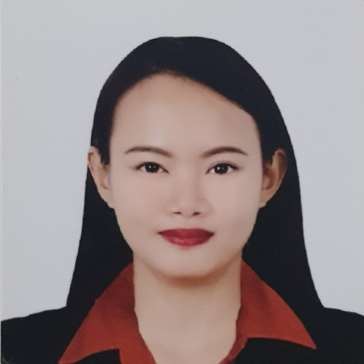
ARIANNE REA B. MIRANDA
2406 One Castilla Place Quezon City, Philippines
Mobile no: +639667688094
Email: ariannereamiranda@yahoo.com

EDUCATION

Bachelor of Science in Hotel and Restaurant Management,
University of the East, Manila, Philippines
2008-2012.
WORK EXPERIENCE

2019 – Present Assistant Waiter
MSC Cruises MV Meraviglia
Geneva, Switzerland

2017- 2019 Buffet Attendant
MSC Cruises MV Seaside and MV Divina
Geneva, Switzerland

2014- 2017 Food Attendant
Rixos The Palm Dubai
Dubai United Arab Emirates

2012- 2013 Rooms Division Intern
American Inn of Bethesda
Bethesda, Maryland, U.S.A

2011 Room Attendant
Xanterra Parks and Resorts
Yellowstone National Park, Wyoming, U.S.A.
AWARD AND CERTIFICATES

Outstanding Performance for the month of August 2016 and February 2017
DIAMOND OF THE YEAR NOMINEE for the year 2015
DIAMOND OF THE MONTH AWARDEE for the month of April 2015INARS ATTE

SEMINARS ATTENDED
NDEDINARS ATTEN
Managing Guest Feedback Training (Rixos The Palm Dubai, June 2016)
Service Excellence Training (Rixos The Palm Dubai, May 2015)
Basic Food Hygiene Training (Rixos The Palm Dubai, October 2014)
CHARACTER REFERENCE

Tony George
Team Leader
Rixos The Palm Dubai
+971559193491
tony.george8@icloud.com
Daniel J. Appolonio
General Manager
American Inn of Bethesda
+1 240 435 1429
dan.appolonio@gmail.com
Tony George
Team Leader
Rixos The Palm Dubai
+971559193491
tony.george8@icloud.com
Daniel J. Appolonio
General Manager
American Inn of Bethesda
+1 240 435 1429
dan.appolonio@gmail.com
Tony George
Team Leader
Rixos The Palm Dubai
+971559193491
tony.george8@icloud.com
Daniel J. Appolonio
General Manager
American Inn of Bethesda
+1 240 435 1429
dan.appolonio@gmail.com
Arlene S. Dela Cruz
Crewing Manager
MSC Crewing Services Philippines
adelacruz@msccs.com

Tony George
Team Leader
Rixos The Palm Dubai
tony.george8@icloud.com

Daniel J. Appolonio
General Manager
American Inn of Bethesda
dan.appolonio@gmail.com

