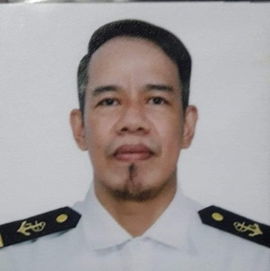
ALFONSO JR. M. MOLDEZ
09993326047
Alfiemoldez054@gmail.com
Wattsapp/Viber:09993326047

Objective: Pursuing opportunity which will allow me to grow professionally, while effectively utilizing my versatile skill set to help promote your corporate mission and exceed team goals.
Summary of Qualifications: Extremely motivated and passionate in whatever I choose to do, Strong interpersonal and communication skills and know how to handle and deal with different kinds of people and circumstances. Equally effective working independently and in cooperation with others.
PERSONAL INFORMATION
NICKNAME: Alfie
AGE: 47 yrs. Old
BIRTHDAY: May 1,1973
ADDRESS: 695 Cupang Muntinlupa City
PLACE OF BIRTH: San Pedro Laguna
SEX: Male
CIVIL STATUS: Married
CITIZENSHIP: Filipino
HEIGHT: 5’8
WEIGHT: 63klg
NAME OF SPOUSE: Joan B. Moldez OCCUPATION: House Wife
NUMBER OF CHILDREN: 4 LIST OF THEIR AGES: 24,22,20,15
NAME OF FATHER: Alfonso Diaz Moldez Senior OCCUPATION: Disease
NAME OF MOTHER: Maximina Medina Moldez OCCUPATION: Disease
ADDRESS: 695 Purok 5 Cupang Muntinlupa City

EDUCATION
ELEMENTARY: Buli Elementary School YEAR GRADUATED: 1986-19987
HIGH SCHOOL: Muntilupa National High School YEAR GRADUATED: 1987-1991
COLLEGE: Philippine Merchant Marine High School YEAR GRADUATED: 1995-1997
COURSE: BSMT

EMPLOYMENT HISTORY
JOB.NO. | NAME OF COMPANY | YOUR JOB | FROM | TO
1 | Red Ribbon | Kitchen Helper | 1995 | Nov 1995
2 | NOPOCOR | General Service | 1998 | 2000
3 | Solid Mills | Fixer (Mechanic) | 2002 | 2003
4 | CMC (California Manufacturing Company)Best Food/Ladyschoice spread | Machine Operator | 1997 | Feb. 1998
5 | Great Effect | Machine Operator | 2003 | Sept. 2003
6 | Heritage Hotel | House Keeping | 2004 | May 2004
7 | Princess Cruises | House Keeping (Laundry) | 2005 | To Present

SSS NUMBER: 33-0362326-2
PASSPORT NUMBER: P2264875A
TIN: 226-274-085-000
NBI NUMBER: M432EAAR37-MU5478660

______________________
APPLICANT’S SIGNATURE

