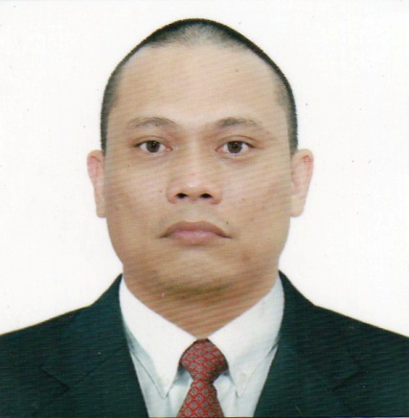
ELEUTERIO SILUD BUCAD JR.
Zone 2 Katipunan, Villanueva Misamis Oriental
Contact Number Philippines: 09157101107
Contact Number Philippines: 09555877726
Email Address: bucadeleuterio@gmail.com

OBJECTIVE PIPE FITTER

PROFILE:

Self-motivated and energetic Pipe Fitter with hands- on experience in installing. Extremely competent at reading and interpreting drawings and blueprints, cutting and threading pipes to appropriate shapes and sizes, testing pipe systems for leaks using complex testing equipment and installing pipe system on board vessels by incorporating safety measures.

EDUCATION:
Vocational: National Certificate II April 22, 2019
Pipefitting
Technical Education and Skills Development Authority
Cagayan de Oro City

Secondary: Tagoloan National High School 1994-1995
Tagoloan Misamis Oriental

WORK HISTORY:

PIPE FITTER September 2019 to August 2020

ENTER ENGINEERING COMPANY
PROJECT: Uzbekistan gas to liquid project ( UZGTL)
Yangi-Nishan, Qashqadaryo Uzbekistan

Job Description:
• Consistently meet light deadlines on large scale projects by going above beyond normal duties.
• Work relentlessly in motivating workers to achieve greater productivity. Repeatedly execute individual projects that impact projects deadlines.
• Blueprint Fluently Effective communication Walk packages and get materials for a team to do the job efficiently, safe and correct.
• Visited the assigned sites and reviewed the task to be accomplished. Determined the best fitting method for each subsystem.
• Reported the complete details of the attained task to General Foreman.
• Interpret and comprehend charts and critical path schedules.
• Evaluate problems and make proper decisions. Make field walks with client reps,
Documents all changes.

PIPE FITTER September 2016 to September 2018

LEIGHTON CONTRACTING (QATAR) WLL
PIPELINES FOR MEGA RESERVOIR
CORRIDOR MAIN 1 PACKAGES A & B
Doha, Qatar

Job Description:
• Installation inside chamber all flanged inverted tee di flanged spigot pipe with internal puddle flange dismantling joint butterfly valve with extended spindle sluice valve with valve spindle flanged socket collar flap valve flange adaptor blank flange.
• Erection pipe laying, install and maintain pipe system.

PIPE FITTER March 2014 to February 2016

YUHAN TECH ARABIA COMPANY
Petro Rabigh II SMP4 Interconnecting Package U01/
Oil and Gas Refinery or Petro Chemical
Wasit Aramco Gas Program NGL Fractionation/Oil and Gas Refinery
Sadara Aramco Feedstock Tank Farm/Oil and Gas Refinery
Rabigh, Wasit, Jubail (K.S.A.)

Job Description:
• General knowledge of pipe system layout, according to specification
• Ability to work from blueprint, drawing layout or other specifications
• Perform all aspect of corrective and preventive work order.

PIPE FABRICATOR July 2010 to December 2013

TARGET ENGINEERING CONSTRUCTION CO.L.L.C.
Ruwais Refinery Expansion 2 (RRE2)
Ruwais Refinery Expansion 7 (RRE7)
Green Diesel Project (GDP)
Abu Dhabi (UAE)

Job Description:
• Able to read and interpret isometric and piping drawings, plot plans and P &ID’s.
•Selects measures, cuts and installs underground and above ground piping systems, joints and connections, including concrete pipe, carbon steel pipe, fiberglass and thermoplastic pipe using hand and power tools and aided by slings and aligning dogs

PIPE FABRICATOR February 2008 to February 2010

CONSOLIDATED CONSTRUCTION COMPANY W.L.L
Khursaniyah Gas Plant Project/ Oil and Gas Refinery
Saudi Arabia (K.S.A.)

Job Description:
• Fabricates from spool or isometric drawings pipe spool pieces and associated Supports and fitments to meet pre and final assembly, in a variety of material and alloys.
• Prepares pipe lengths and fittings for fit-up and sets up all types of weld joints prior to completion by welder
• Selects, inspects and uses rigging aids such as block and tackle, chain hoist, come-along, jack and tagger. Aligns piping against thrust blocks.
• Completes final installation of piping system with required fabricated spools, pipe, fittings, valves, gaskets, bolts, supports and hangers.
•Prepare completed pipe system for hydrostatic testing in accordance with approved test packages.

TRAINING AND SEMINARS:

- Construction Occupational Safety and Health (COSH)
Rodisa Bldg. A. Velez-Gomez St. Cagayan de Oro City
Certificate Number MSRS-COSH-18-01833
Training Date December 6-9, 2018
- International Association of Safety Professionals (IASP)
Mussafa, Abu Dhabi U.A.E.
Certificate Number 505655
Training Date September 20-27, 2013
- Institution of Occupational Safety & Health (IOSH)
Mussafa, Abu Dhabi U.A.E

Certificate Number 119644
Training Date February 1-2-9-10,

