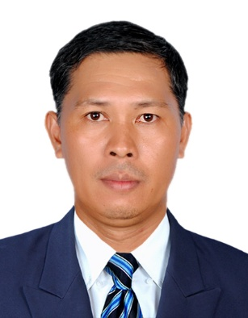
Jorge Casaljay Estrada
jce.estrada23@yahoo.com.ph
+639084923561

OBJECTIVE
A suitable position in an organization seeking an extraordinary record of performance, exceeding sales targets and enthusiastic customer relations.

PERSONAL STRENGTH
I am well motivated person, with strong artistic sense, good artwork and creativity, patient, enthusiastic, hardworking, flexible, fast learner, trustworthy, team player and achiever. I can able to remain calm and efficient under pressure.

WORK EXPERIENCE/ATTAINMENTS

2012 – Present – Prestige Cars, BMW Inc.
Makati Philippines
Certified Service Technician
- Trouble Shooting ( Electrical / Mechanical ) Repairs
- Performed Engine and Manual / Automatic Transmission
- Diagnosing Engine and Transmission Fault
- Istrap Program and Control Unit
- Replacing and Removing all automotive Mechanical/Electronics/Electrical Parts.

2011 – 2012 Autohaus BMW
Dealership ( M.Power/Motorrad /Security vehicle Automobile)
Quezon City, Philippines
Parts Service Counter
- Releasing Order
- Distributing parts Accessories to Workshop

2009 – 2011 Autohaus BMW Dealership
Dealership ( M.Power/Motorrad /Secuirty vehicle Automobile)
Quezon City Philippines
Parts Counter Salesman
- Distribute Parts To Client
- Performed Parts Inventory
- Performed Inbound & Outbound Bearing
- Knowledgeable about Warranty and Directly advise Client for the warranty Procedure.
- Performed Report Monthly Status (Sales / Client and Damage Parts )

2002 – 2009 Autohaus BMW
Dealership ( M.Power/Motorrad /Security vehicle Automobile)
Quezon City Philippines
Parts Expedite
- Pick up genuine parts and Car accesories to Head Office
( ACC – asian car makers ) warehouse Depot
Delivery all Genuine parts to all Respective BMW Branches.

2001 – 2002 DATACOM SYSTEM CORPORATION
Gil.Puyat, Makati City
- Delivery Driver all Genuine parts to all sharp photocopy machine

2000 – 2001 A.M Oreta & CO.
Adritiaco, Manila (Office)
Caloocan City (Plant)Philippines
- Driver Heavy Equipment

1999 – 2000 Taikishia Philippines Inc.
Calamba Laguna Philippines
Pipe Welder
- Pipe Welder
- Smaw Welder
- Fabrication

1998 – 1999 Daromar Ready Mix Industries Inc.
Pasig City, Philippines
Welder and Denter
- Welder and Denter Specialist
- Repair all Transit Mix
- Repair all The batching Plant
- General Maintenance

1993 – 1997 – Portland Concrete phils, Inc.
Santolan, Pasig City, Philippines
Welder / Denter / Mechanic
- Welder and Denter Specialist
- Repair all Transit Mix
- Repair all The batching Plant
- General Maintenance

1992 – 1993 Federal Builders Inc.
Makati city, Philippines
Welder
- Smaw Welder
- Fabrication

1990 – 1991 Well Wee Machine Shop
Mecauyan, Bulacan Philippines
Welder
- Smaw Welder
- Fabrication

TRAINING/SEMINAR ATTENDED

August 08 – 10, 2011 THE JOY OF BMW
GRYPHON
LEARNING & DEVELOPMENT CONSULTANTS

August 14 – 16, 2011 COMMUNICATION SKILLS WORKSHOP
GRYPHON
LEARNING & DEVELOPMENT CONSULTANTS

August 31, 2011
Sept. 01 – 02, 2011 LEADERSHIP & MANAGEMENT
GRYPHON
LEARNING & DEVELOPMENT CONSULTANTS

Sept.12 – 14, 2011 TOTAL CUSTOMER FOCUS
GRYPHON
LEARNING & DEVELOPMENT CONSULTANTS

Sept 26, 2011
Oct. 4 – 5, 2011 THE BMW PROFESSIONAL
GRYPHON
LEARNING & DEVELOPMENT CONSULTANTS
ACC BMW, Philippines

Nov. 09 – 10, 2010 CASTROL RED CARPET TRAINING (ENGINE OIL)
Autohaus BMW, Libis Quezon City

October 09, 2011 PARTS AND ACCESSORIES SALES ADVISOR CERTIFICATION
Foundation I and II
BMW Group Regonal Training Centre
Johor Bahru, Malaysia

July 2, 2014 S55 (M ENGINE) INTRODUCTION TRAINING
BMW Group Regional Training Centre
Kuala Lumpur, Malaysia

May 10, 2016 EQUIPMENT OPERATIONS AND PREVENTIVE MAINTENANCE
HUNTER WHEEL ALIGNMENT Model KDSII
Autoreach Company, Inc.
Las Piñas, Philippines

June 28, 2016 CERTIFICATE SERVICE TECHNICIAN
Asian Carmakers Corporation, Philippines

SUMMARY OF QUALIFICATIONS/SKILLS
* Driving skills
* Proficient in Microsoft Office applications
* Excellent oral and written English
* Knowledge in customer relationship
* Ability to work with minimal supervision

HIGHLIGHTS OF ACCOMPLISHMENTS
Field of Study : Automotive SPECIAL COURSE
Institute/University : Don Bosco Technical Institute Makati
Graduation Date : 2015 – 2016

Field of Study : REF. & ARICON TECHNICIAN
Institiute : FAST-TECH TRAINING CENTER
Graduation Date : 2009

PERSONAL INFORMATION
Date of birth:  Place of birth: | 23 April 1975  Calbayog City, Samar
Marital state: | Married
Gender: | Male
Nationality: | Filipino

I hereby certify that the information is true and correct
to the best of my knowledge and belief.

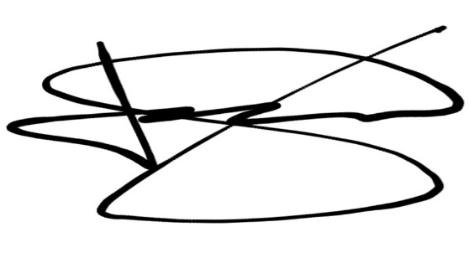
JORGE C. ESTRADA
Applicant

