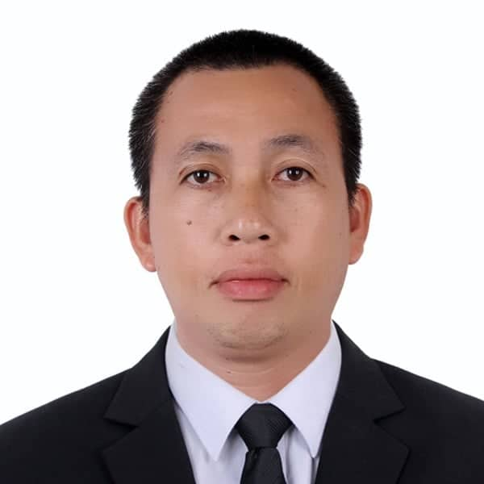
Joelcie . Ignacio
Rc-11 Area G. Brgy. Citrus
City of San Jose Del Monte Bulacan
0906-971-1113
joelcieignacio72@gmail.com
CURRENT JOB:
Philippine Airlines Ramp Operation Bus driver

OBJECTIVE:

I would appreciate the opportunity to work for your company by filling the trailer truck driver position and putting my past experience to good use.

PERSONAL DATA:

Age : 48 years old
Place of Birth : San Jose Del Monte, Bulacan
Birthday : February 10, 1972
Sex : Male
Civil Status : Married
Citizenship : Filipino
Religion : Catholic
Height : 5’8
Weight : 72kg
Father’s Name : Ernesto G. Ignacio
Occupation : Farmer
Mother’s Name : Mercedes F. Delos Santos
Occupation : Deceased

EDUCATIONAL BACKGROUND:

SECONDARY SAPANG PALAY NATIONAL HIGH SCHOOL
Fatima IV Sapang Palay Area E, City of San Jose del Monte Bulacan
Year Graduated 1985-1989

PRIMARY BAGONG BUHAY G. ELEMENTARY SCHOOL
Citrus Area G, City of San Jose del Monte Bulacan
Year Graduated 1979-1985

WORK EXPERIENCE:

2016 – 2020 Bus Driver/Philippine Airlines Air21 Ube Express Inc

2011 – 2016 Plant Operation Driver Eagle Cement Corporation
2006 – 2010 Bus Driver/City Operation IBL Transit Corp.
2002 – 2005 Bus Driver/City Operation A-7 Tours and Transport
2000 – 2002 Bus/Truck Trailer Driver RBJ Industries SDN BHD Brunei

JOB DUTIES:

- Conduct pre-trip inspection to ensure good condition and safe operation of the vehicle
- Operating two way radio
- Monitor all arrival flight and departure
- Transporting passenger from aircraft to international and domestic bus gate
- Answering all passenger inquiries
- Transferring restricted and non restricted passenger from terminal to terminal
- Transferring passenger to international and domestic connecting flight
- Advice passenger to be seated and orderly while on vehicles
- Comply traffic regulation to operate vehicle inside the airport ramp
- Always used white vehecular lane only at all times
- Provide safe courteous and comportable transportation of passenger
- Assist elderly passenger and those with luggage to get on and off the bus
- Prepare and submit reports that my include the number of passenger or trips,hours
worked,mileage and fuel consumption
- Maintain the cleanliness interior and exterior of the bus to become presentable to the public
- Report accident and incidents while on duty
- Return and secure vehicles at end of run

I hereby certify that the above information is true and correct to the best of my knowledge and beliefs.

______________________________
Joelcie D.S Ignacio
Applicant

