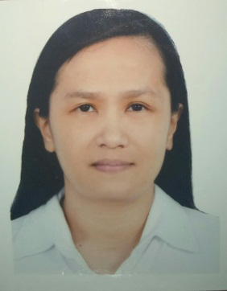
SHERYL V. JOSE
#5500 ME(NR) MASIIT
BRGY. MASIIT, CALAUAN
LAGUNA , PHILIPPINES ( 4012 )
Contact Info: +639983259035
Email Address: sherylv_jose@yahoo.com

PERSONAL INFORMATION
AGE : 42yrs old
BIRTHDATE : April 22, 1978
BIRTHPLACE : Calauan, Laguna
CIVIL STATUS : Married
WEIGHT : 65 klg
HEIGHT : 5’3”
SEX : Female
RELIGION : Roman Catholic
CITIZENSHIP : Filipino

OBJECTIVE :
To make the most of my ability in performing my duties,
responsibility and obligation in work as well as to contribute
to the company in attaining it’s goal and objectives.

SCHOLASTIC BACKGROUND :
Vocational : San Pablo Colleges, San Pablo City Philippines
Liberal Arts (undergraduate) S.Y. 1995-1996
Secondary Education : San Antonio De Padua College
Pila, Laguna Philippines S.Y 1993-1994
Elementary Education : Calauan Elementary School
Calauan, Laguna Philippines S.Y. 1989-1990

WORK AND TRAINING EXPERIENCES :
CHIPBOND ELECTRONICS COMPANY (formerly SIMPAL ELECTRONICS)
: Production Operator (Q.C)(T.A)
Kaohsuing Export Processing Zone
Qianzhen District Kaohsiung City
Taiwan R.O.C.
(June 2008 up to January 5, 2020)
HITACHI PHILIPPINES: Sr. Production Operator
SLG Training Department
S.E.P.Z Laguna Technopark
Binan, Laguna Philippines
(Jan./1998 – June/2008)
FUJITSU PHILIPPINES : Production Operator HGA Dept.
MR Head Division
Carmelray Laguna Technopark
Canlubang, Laguna Philippines
(May/1996 – Dec./1997)
SEMINARS AND TRAININGS ATTENDED :
*Training on handling hazardous materials
*OHSAS 18001
*ISO 9001 : 2000 Awareness Program
*ISO 9001 : 2000 Appreciation Program and Documentation
SPECIAL SKILLS AND INTEREST :
*Can fulfill responsibilities and obligations with minimum supervision.
*With good moral and written communication.
*Fast learner, easy to grasp instructions after it was being given.
*Willing to extend or render overtime if needed without hesitation.
*Knowledge on English communications.
*Knowledge on basic computer skills.

I hereby certify that the above information is true and correct to the
best of my knowledge and beliefs.
SHERYL V. JOSE

