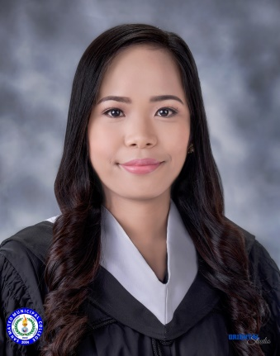
DEBBIE M. AMBEGUIA

Ph2 Blk 7 Lot 33 Green Breeze Subd. San Isidro, Rodriguez Rizal
Contact: 09501720452
Email Address: debbieambeguia0318@gmail.com

CAREER OBJECTIVE

To be a part of a good and strong company where I can use and enhance my knowledge and skills to develop my abilities and to build a good working relationship at the same time.

PERSONAL INFORMATION

Date of Birth: May 01, 1999

Marital Status: Single

Citizenship: Filipino

Language Spoken: Filipino, English

EDUCATION

Bachelor of Science in Psychology
San Mateo Municipal College
Gen. Luna Street, Guitnang Bayan 1, San Mateo Rizal
June 2015 – April 2019

Mapandan National High School
Poblacion Mapandan, Pangasinan
2011-2015

Lambayan Elementary School
Lambayan Mapandan, Pangasinan
2005-2011

SKILLS
- Proficiency in Microsoft Office applications
- Leadership skills
- Proficiency in English both written and verbal
Communication

EXPERIENCE

On-the-Job Training ( School Setting )
St. Joseph’s College of Rodriguez
J.P Rizal St. Balite Rodriguez, Rizal
February - March 2019

On-the-Job Training ( Clinical Setting )
Armed Forces of the Philippines Health Service Command
V Luna Ave, Quezon City
January – February 2019

On-the-Job Training ( Industrial Setting )
Department Of Social Welfare and Development ( DSWD ) Central Office
Batasan Pambansa Complex, Constitutional Hills, Quezon City
June – August 2018

SEMINARS ATTENDED

- POSITIVE PSYCHOLOGY: “HOPE AND TRAIT”
San Mateo Municipal College
March 9, 2018

- NATIONWIDE HANDS-ONLY CARDIOPULMONARY RESUSCITATION CAMPAIGN 2018
Jose F. Diaz Stadium, San Mateo Rizal
July 16, 2018

- M.Q.C.Q.C INTER-PSYCH FAIR 2018
Mary the Queen College of Quezon City
August 29, 2018

- IMPOSSIBLE TO I’M POSSIBLE: PERSONALITY ALIGNMENT IN THE WORKPLACE
Roosevelt College, Cainta
September 22, 2018

- EMOTIONAL FIRST AID WORKSHOP AND ORIENTATION ON MENTAL HEALTH LAW
San Mateo Municipal College
September 28, 2018

- HEALING WOUNDS THROUGH EMOTIONAL FIRST AID
Mary the Queen College
January 21, 2017
- LEADING THE ORGANIZATION WITH ZEAL COMPASSION
San Mateo Municipal College
August 4, 2017

- HUMAN BRAIN ANATOMY WORKSHOP
San Mateo Municipal College
August 18, 2017

- THINK BEFORE YOU CLICK
San Mateo Municipal College
September 14, 2017

- HELPING EACH OTHER, BUILD’S TOGETHER
GB I Gymnasium, San Mateo, Rizal
September 19, 2016

- THE BASICS OF COUNSELING
San Mateo Municipal College
September 23, 2015

- GENDER ISSUES IN DEVELOPMENT: MOVING AHEAD TOWARDS EQUALITY
San Mateo Municipal College
October 2, 2015

REFERENCE

Filipino M. Salamat
Guidance Counselor
San Mateo Municipal College
09202214256

I hereby certify that all the information above is true and correct.

DEBBIE M. AMBEGUIA

