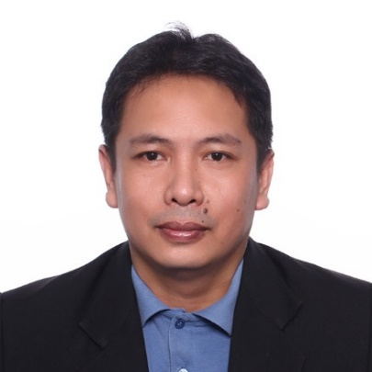
Jason Saludo Namuco
811 Purok 6 Sucat Muntinlupa City
Cellphone: 09071282989
Phone: 277-22-93
Email: jhnjnas33@yahoo.com
Dedicated and qualified Machinist with more than 5 years of experience. Adept at working closely with supervisors and coworkers to achieve and maintain long-term operation success. Eager to contribute and determined to team success through hard work.

Work Experience

Position: Machine Operator
Duration: July 30, 1999 to June 12, 2002
Company: LIPENG enterprizes
Location: Changhwa, Taiwan

Position: CNC Lathe Machine Operator
Duration: July 19, 2009 to August 12, 2011
Company: OSUNG Machine
Location: 322 Anseong Si, Kyeonggido, South Korea

Position: Machinist
Duration: September 20, 2005 to February 26, 2009
Company: Dawoo Engineering
Location: 158 Lot 3, Namdong Industrial Park, Incheon, South Korea

Position: Utility Vehicle (UV) Express Driver
Duration: 2014 up to present

Personal Data
Age: 43
Date of Birth: September 11, 1976
Gender: Male
Civil Status: Married
Height: 172 cm
Weight: 95 kg
Nationality: Filipino
Religion: Roman Catholic

Educational Background
College: Jose P. Laurel Polytechnic College
Malvar, Batangas
Date Graduated: 1993-1995
Course: Drafting Technology
High School: Palahanan National High School
San Juan, Batangas 1984-1989

