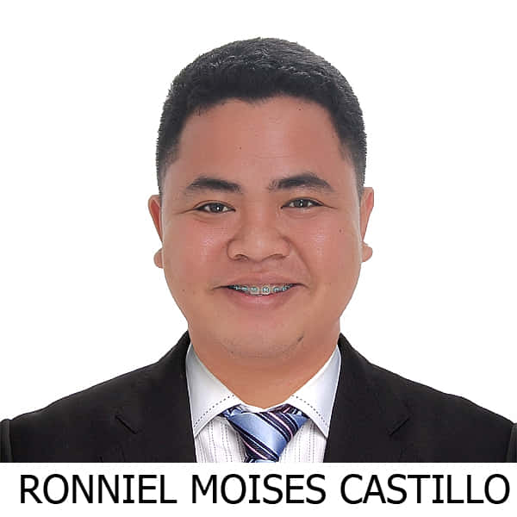
RONNIEL MOISES CASTILLO

Blk 14, Lot 7 Isarog St. Primavera Homes Darasa

Tanauan City, Batangas

Contact Number: 09164229961

Email Address: ronnielcastillo1827@gmail.com

CAREER OBJECTIVES:

To work for any suitable position commensurate to my qualifications, in a challenging and progressive environment which will utilize my skills and knowledge ensuring constant professional and personal growth, at the same time help the company in its growth and development.

EDUCATIONAL BACKGROUND:

Tertiary : University of Batangas
Maraouy-Balete Rd, Lipa City, Batangas
Bachelor of Science in International Hospitality Management
School Year 2016 - 2020

Secondary : New Era University
Lipa City, Batangas
School Year 2011 - 2015

Primary : Tanauan South Central School
Tanauan City, Batangas

ON THE JOB TRAINING:

CRIMSON HOTEL
Filinvest City, Alabang Muntinlupa City
February 17, 2020 – March 6, 2020

THE FARM (SAN BENITO)
119 Brgy. Tipakan, Lipa City, Philippines
June 18, 2018 – August 3, 2018

WORK EXPERIENCE:

AURELIO’S CATERING SERVICES
Waiter
October 19, 2019 – November 12, 2020

ACHIEVEMENTS:

Food and Beverage NCII
Technical Education and Skills Development Agency (TESDA)
University of Batangas – Main Campus
Hilltop Rd., Batangas City

Bread and Pastry Production NCII
Technical Education and Skills Development Agency (TESDA)
University of Batangas – Main Campus
Hilltop Rd., Batangas City

Housekeeping NCII
Technical Education and Skills Development Agency (TESDA)
University of Batangas – Main Campus
Hilltop Rd., Batangas City

Front Office NCII
Technical Education and Skills Development Agency (TESDA)
University of Batangas City- Main Campus
Hilltop Rd., Batangas City

Events Management NCIII
Technical Education and Skills Development Agency (TESDA)

TRAININGS AND SEMINARS ATTENDED:

Developing Students Competencies and Customer Service in Tourism Hospitality Industries
University of Batangas

Achieving Distinctiveness through Hospitality Innovation
Council of Hotel and Restaurant Educators of the Philippines (COHREP)
Lyceum of the Philippines University-Laguna
Makiling Highway, Calamba City, Laguna

Happy ka ba? Campaign Coffee Farming and Entrep Day
University of Batangas Lipa Campus
May 4, 2018

PERSONAL INFORMATION:

Date of Birth : June 27, 1999
Age : 21
Gender : Male
Place of Birth : Matain, Subic Zambales
Civil Status : Single
Nationality : Filipino
Religion : Iglesia Ni Cristo
Height : 5’7
Weight : 80 kg
Father’s Name : Ronnie Crisostomo
Mother’s Name : Oretes L. Castillo

In case of emergency : Erlinda Castillo
Tanauan City, Batangas
09386732367

CHARACTER REFERENCES:

Mrs. Mila Dela Cruz
CTHM Department Head (University of Batangas Lipa Campus)
Lipa City, Batangas
Contact Number: 0917-577-4772

CONFORME:

By signing below, I hereby certify that the above mention information is true and correct to the best of my knowledge and belief.

_____________________
Ronniel Moises Castillo

