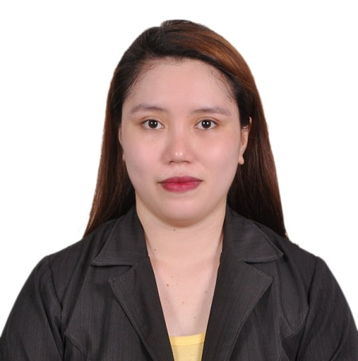
AILEEN CLAIRE SARABILLO DAGPIN,RN
Sto. Niño, New Clarin, Bansalan
Davao Del Sur
aileendagpin@gmail.com
Contact No. +639388593478

Objective:

Seeking a challenging opportunity where I will be able to utilize my strong organizational skills, educational background, and ability to wrk well with people, which will allow me to grow personally and professionally.

Personal Data:

Birthdate: February 12,1996
Birthplace: Nabunturan, Compostela Valley
Civil Status: Single
Religion: Roman Catholic
Height: 5’5
Weight: 65 Kilograms

Educational Background:

Primary Vedasto F. Corcuera Elementary School, 2008
With Honors

Secondary Holy Cross Academy of Digos, 2012
Highschool Diploma
College Cor Jesu College, 2012-2014
Polytechnic College of Davao del Sur, 2015-present
Dean’s Lister, Class President, Campus Journalist, Health Care Services NC II Passer, Caregiving NCII Passer
With Academic Distinction, Best in Emergency Room Award

Board Exam December 2018

Work Experience:
April 11, 2020– Present Medical Center of Digos Cooperative
Regular Staff Nurse
ER Triage/Isolation Area/ Emergency Room

January 07, 2019 - April 10, 2020 Medical Center of Digos Cooperative
Staff Nurse
Medical- Surgical Ward

November 2017-April 2018 Kayden Blaise Birthing Home
Nurse Attendant

Interest/Skills/Trainings

- MS Office Literate
- Computer Literate
- Caregiving NCII Passer
- Health Care Services NCII Passer
- IV Insertion/Therapy
- Pain Management
- Administration of blood and blood products
- Critical Thinking
- Problem Solving Skills

References:

Shajanie Ganotice, RN, LPT
Clinical Instructor
Polytechnic College of Davao Del Sur
Contact No. +639095164503

Jaypee Bacalso, RN, MAN
Clinical Instructor/ Assistant Chief Nurse
Davao Del Sur Provincial Hospital
Contact No. +639988894458

Braulia Lee Florentino, RN, MAN
Chief Nurse
Medical Center of Digos Cooperative
+639381532439

