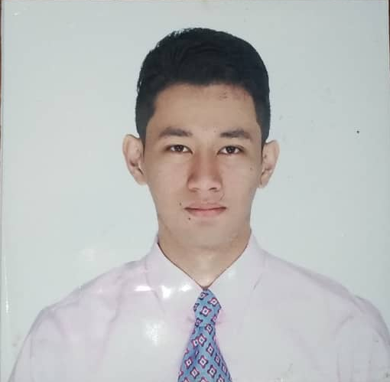
Marold Cesar C. Guansing Jr.
58 M.A Fernando St. San Roque
Angat, Bulacan, Philippines 3012
+6581220643
maroldguansing@gmail.com

Job Objective:
Seeking a position in a fast paced airline facility where my diverse technical skills and background will be fully maximized to achieve corporate objectives.
Summary of Qualifications:
- EASA Certified Level 1 Aircraft Maintenance Engineer
- Strong experience with light to heavy maintenance checks of aircrafts.
- Sound knowledge with Aircrafts like Airbus A320 Family, A330, A340 and A380
- Familiarity with aircraft ground handling and common maintenance practices
- Ability to complete aviation authorities’ maintenance forms, workbooks and service logs
- Knowledgeable in safety regulations, maintenance manuals, service bulletins, blueprints, diagrams and schematics
Licenses and Authorizations:
- Civil Aviation Authority of the Philippines – Airframe and Powerplant License # 131916
- Aircraft Maintenance Engineer Level 1 Authorization (A380 fleet) – British Airways, Lufthansa, Qantas, Korean Air, Asiana Airlines
Work Experience:

Aircraft Maintenance Technician (A&C) August 2019 - Present
ST Engineering Aerospace
Changi, Singapore

Duties and Responsibilities:
- Performed Removal, Servicing and Installation of Aircraft Components such as Engine, Flight Controls, Door and etc.
- Performed Inspection, Rectification and Lubrication of Components.
- Performed removal and installation of wheels and brakes for axle sleeve inspections.
- Performed towing and marshalling from base hangars to airport terminals vice versa.
- Performed removal and installation of crew oxygen bottle and passenger emergency oxygen containers
- Determines defects, unsatisfactory and unsafe condition present in aircraft and diagnoses causes to pinpoint areas or system where corrective actions are necessary.
- Maintains a clean and neat working area at all times and follows all the company safety rules and regulations.
- Accomplishes routine and non-routine checks in accordance with the customers’ maintenance program.

Aircraft Maintenance Engineer (Airframe and Powerplant) August 2015 – August 2019
Lufthansa Technik Philippines
Metro Manila, Philippines

Duties and Responsibilities:
- Performs light to heavy checks of different aircrafts.
- Examine and inspect aircraft components, including landing gear, hydraulic systems, and flight control surfaces to locate cracks, breaks, leaks, or other problem.
- Perform removal, installation and servicing of aircraft engines.
- Perform removal, installation, lubrication and inspection of engine components including fan blades.
- Conducts removal, installation, repair and overhaul damage parts of components of the aircraft such as Galleys, OSB, Lavatory, Sidewall Ceiling Floor Panels, Pax Seat, Crew Rest and other aircraft components.
- Performed Modification/ Rigging and Adjustment of Pax Doors
- Re assembled components check them for operating efficiency and general condition and serviceability in accordance with established maintenance schedule and rectifies defect of malfunctions recorded by the flight crew.
- Performed nitrogen filling of the hydraulic power accumulators and the wheel tires which is also undergo inspection and check prior to flight.
- Performed general lubrication of flight controls such as rudder, elevators, trimmable horizontal stabilizer, spoilers, ailerons, flaps.
- Performed hydraulic servicing
- Performed removal and installation of wheels and brakes for axle sleeve inspections.
- Performed towing and marshalling from base hangars to airport terminals vice versa.
- Performed removal and installation of crew oxygen bottle and passenger emergency oxygen containers
- Determines defects, unsatisfactory and unsafe condition present in aircraft and diagnoses causes to pinpoint areas or system where corrective actions are necessary.
- Maintains a clean and neat working area at all times and follows all the company safety rules and regulations.
- Accomplishes routine and non-routine checks in accordance with the customers’ maintenance program.

“Maintenance Training Program for A/P Base Mechanic” June-August 2015
Lufthansa Technical Training Philippines
Pasay City

Interisland Airlines Philippines – Aircraft Mechanic Helper
December 2014 – April 2015
Type of Aircraft: Cessna and Beechcraft
- Check for corrosion, distortion, and invisible cracks in the fuselage, wings, and tail, using x-ray and magnetic inspection equipment.
- Clean, refuel, and change oil in line service aircraft.
- Conduct routine and special inspections as required by regulations.
- Examine and inspect aircraft components, including landing gear, hydraulic systems, and de-icers to locate cracks, breaks, leaks, or other problem.

Education:
Philippine Air Transport and Training Services (PATTS) College of Aeronautics
Bachelor of Science in Aircraft Maintenance Technology
San Isidro, Paranaque City, Philippines
March 2015
Graduated Cum Laude
Personal Skills:
- Knowledgeable in Maintenance Manuals such as AMM, CMM, IPC and etc.
- Excellent in Aircraft Documentation and Representation.
- Good Communication and Writing Skill
- Excellent in teamwork and leadership skill
- Can work under pressure with consistent best results.
- MS Office Proficient and HTML and Webpage Design Proficient
- Flexible team player who prospers in a fast-paced work environment

