Rodeline E. Limpio
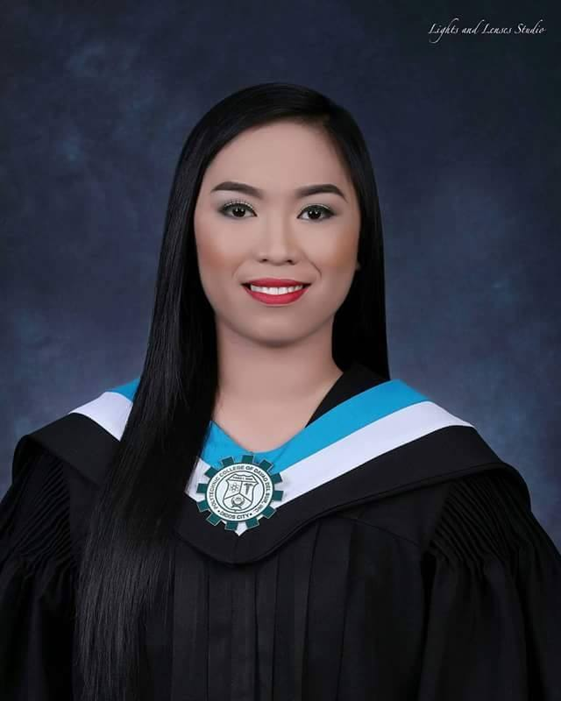
Brgy. Kiagot
Digos City, Davao del Sur
09460040404/09127256078
rodelinelimpio2018@gmail.com

A graduate in Bachelor of Science in Nursing, and passed the November 2017 Nursing Licensure Exam ,and passed National Council Licensure Exam (Texas) last September 2019, Computer Literate, has good interpersonal skills, trained on Basic Life Support (BLS), works well under pressure and is willing to learn and explore new things.

PERSONAL INFORMATION,

Born November 16th, 1996 in Digos City (Philippines)

Citizenship: Filipino
Marital status: Single
Age: 23
Father’s Name: Juanito M. Limpio Sr.
Mother’s Name: Carolina E. Limpio

Educational HISTORY

2013 – 2017 polytechnic college of davao del sur
Bachelor of Science in Nursing (BSN)
- Cum Laude
- Best in Operating Room awardee
- Consistent Deans Lister

2009 – 2013 Digos city national high school
- Consistent Pilot Section student

2003 - 2009 Badiang elementary school

- Valedictorian

EMPLOYMENT HISTORY

2018- 2020 ALFONSO G. LLANOS HOSPITAL
Staff Nurse
- Provide direct quality primary care to patients including daily monitoring, recording and evaluating of medical conditions up to 12 patients per day.
- Coordinate workforce management objectives with a focus on individual, departmental and hospital-wide initiatives.
- Interact and communicate with patients at all ages and ethnic backgrounds, giving quality medical care and treatment.
- Set up referrals with specialists to handle patient needs.
- Coordinate patient care with hospital standards.
- Educate patients and caregivers on health care processes and protocols.
- Effectively communicate with physicians to deliver information to patients on test results, treatment options and recommended procedures.

