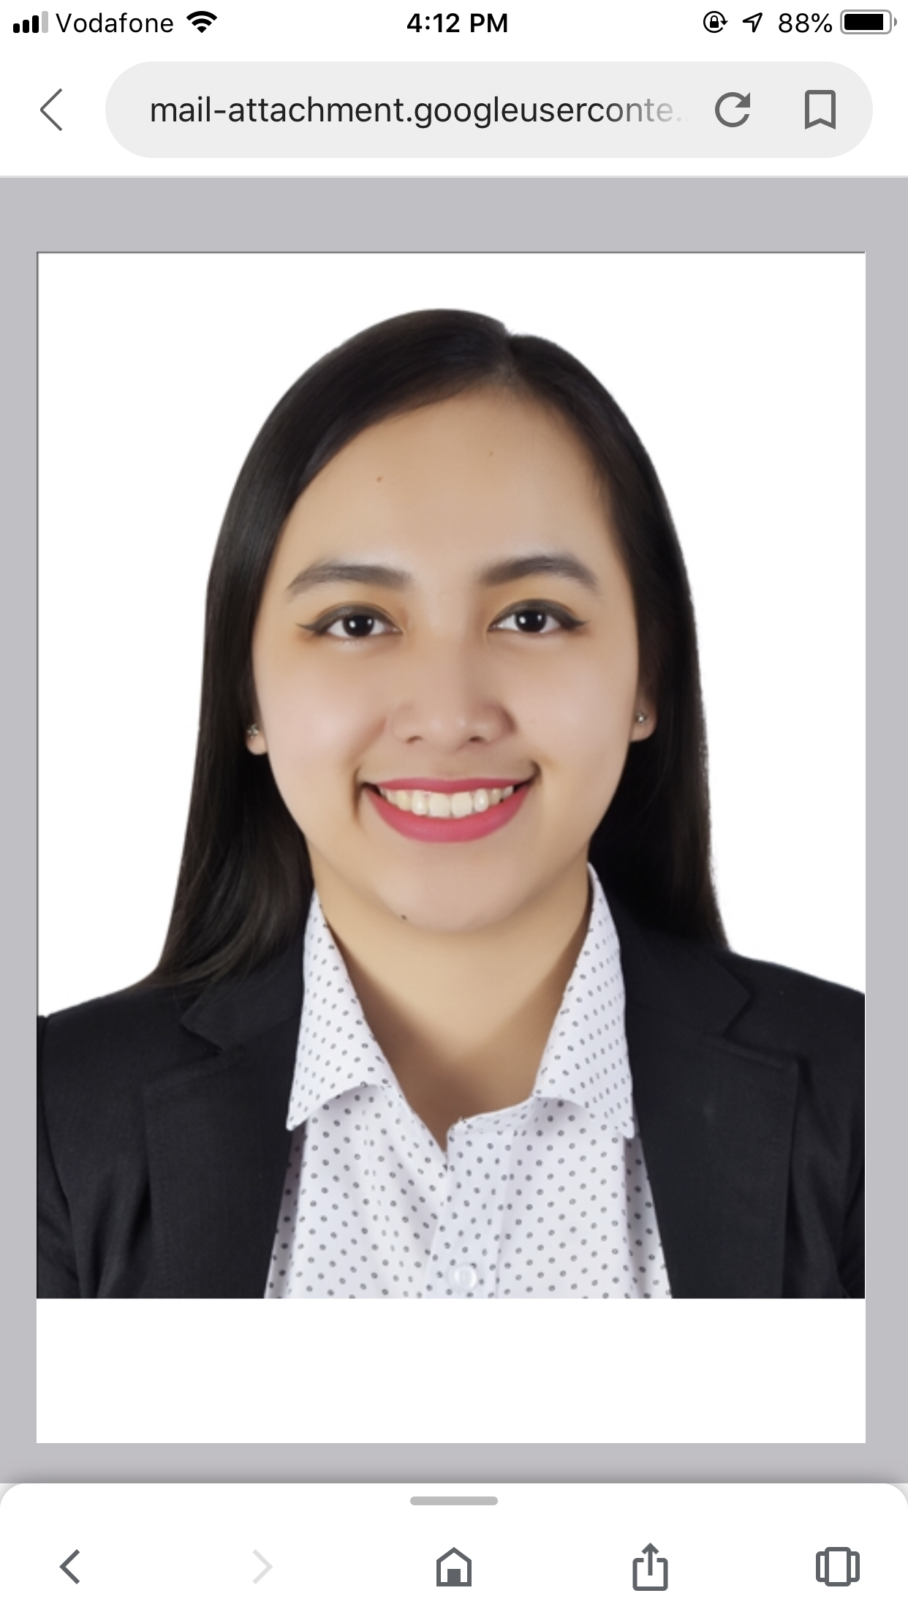
MARIA NOREEN GARCIA LEDESMA
Paulino Era St. Basud, Camarines Norte
Contact No.(+974) 3115 3093
E-mail Address : Naureenledesma@gmail.com

OBJECTIVE:

To obtain a challenging position in your company where I can utilize my management skills and develop my personality, as well as to help the company to the best of my ability and prepare for the trials that I have to face in the future.

EDUCATIONAL BACKGROUND:

Graduate BACHELOR IN FOOD SERVICE MANAGEMENT
Camarines Norte State College
Daet, Camarines Norte
2010 – 2014

Secondary BASUD NATIONAL HIGH SCHOOL Basud, Camarines Norte
2006 – 2010

Primary BASUD ELEMENTARY SCHOOL Basud, Camarines Norte
2000 – 2006

WORK EXPERIENCE:

Mezen International
Present Café Vergnano
July 24, 2020 Team Leader
February 28, 2018 Barista

November 18, 2017 Almana Restaurant and Food Corp.
/ October 2, 2015 McDonalds Qatar/McCafe Barista

February 10, 2014 ON THE JOB TRAINING
/ November 25, 2013 VILLA CACERES HOTEL,Naga City Food and Beverage Service assigned in
Banquet and Restaurant; Kitchen Area and Housekeeping Department

November 2, 2014 STARHARVEST FOOD Inc.
/June 2, 2014 JOLLIBEE DAET PIMENTEL
Service crew; Food preparations;
Serving and Cleaning Facilities

February 15, 2013 RNM FOOD CORPORATION
/ August 23, 2012 JOLLIBEE DAET BAYAN
Service crew; Food preparations;
Serving and Cleaning Facilities

SEMINARS/LECTURES ATTENDED:

September 19, 2012 Economics Seminar
With the theme “Environmental Advocacy for Sustainable Economy”
Camarines Norte State College

October 27, 2012 Greenwich – Daet
FOOD SAFETY SEMINAR
Food Service and Cleanliness

PERSONAL BACKGROUND

Born on November 28, 1993 in Basud Camarines Norte.
Can prepare and entertain clients. Courteous and caring, trustworthy, humility to listen and learn.Can communicate well with other people.

Height: 5’4 Age: 27

Interest/Skills

Music, Painting, Cooking, Swimming.

Character References upon request.

