JUANITA EBEN VILLORIA 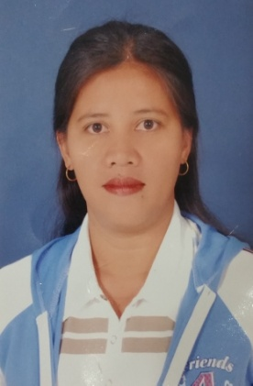Block# 9, Street# 8, Building# 9 Behind
MC DONALD OLD SOUK ; SALMIYA
Contact # 50555140
Email Address: florencejean082010@gmail.com

DESCRIPTIVE QUALIFICATION:

A self motivated hardworking in terms of duties and responsibilities for the success of the company. To do my best and my willingness to undergo extensive trainings and orientations. To expand my knowledge and experience in life.

Working experiences:

- FATEMAH CHOCOLATE : Sales Lady October 2019 to Present
- COCOA CABANA RESTO : Supervisor Jan. 2014 up to September 2019
- DOREMI Lounge : Server/ Waitress October 2013- Dec. 2013
- KAKAO Company : Production Staff June 2009- October 2013
- LABAQUETTE Gen Training Com : Production Staff January 2006- May 2009
- Sable Trading Company : Sweet Maker May 2002- August 2004
- Gulf Catering Center : Waitress September 2001- March 2002
- Gaisano, Cebu City : Sales Lady June 2000- May 2001

EDUCATIONAL ATTAINMENT:

College (1999-2000) : Bachelor of Science in Commerce
Major in Banking and Finance
Sounthern Mindanao Colleges Pangadian City

Secondary Level : Lourdes Academy High School
San Miguel, ZAMBOANGA, DEL SUR

ELEMENTARY LEVEL : SAN Miguel Central School

PERSONAL DATA :

NATIONALITY : Filipino
RELIGION : Catholic
DATE OF BIRTH : June 24, 1978
CIVIL ID # : 27801240836
PASSPORT # : P1019541A
DATE of Expiry : November 26, 2021
STATUS : Married
Language Spoken : Filipino, English, Arabic

I hereby certify all information written above is true and correct to the best of my knowledge.

___________________________
JUANITA EBEN VILLORIA
Applicant

