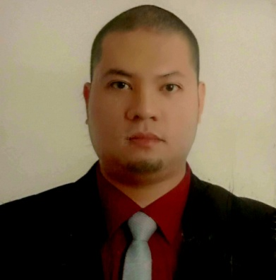
Ronwaldo A. Hernandez
Address: 1012 Feliza Subdivision Aldama st.
Baliuag, Bulacan Philippines 3006.
Mobile No. +639224722270
Email: coolron22@yahoo.com

Objectives: To make good use of my knowledge and skills and at the same time explore new areas of capabilities by being part of your team.

Education:

Degree: Bachelor of Science in Computer Science.
Baliuag Universty
Baliuag, Bulacan.
Year Graduated: 2004

Secondary: Baliuag University
Baliuag Bulacan.
Year Graduated: 1999

Work Experience:

April 2006 to 2013 Pro-Cell Center
Banga 1st Plaridel Bulacan.

Store Manager:

- Plans action to be taken to achieve operational target and sales quota.
- Handles customer complaints when needed.
Prepare store operational budget and monitors periodically the actual expenditures.
- Manage cost and overheads and all other factors affecting the profitable performance of the store.
- Forecast, analyzes sales and overall business performance according to the sore requirements.

June 2013 up to present. Jack and Tessie Meat shop.
Benigno Aquino St
Tangos Baliuag, Bulacan.

Manager:

- Track sales report and order products to meet customer requirements and increase profits.
- Minimize out-of-stock and overstock to ensure fresh merchandise.
- Ensure associates run equipment safely.
- Handle staff duty like trimming and cutting.
- Welcome and receive orders from customers.

On the job training

July 2003 to October 2003 United Overseas Bank
Baliuag, Bulacan.

Clerk:
- Accepting deposit and cashes checks, handling cash to customers after validating the signatures on the checks and fund availability,
- When handling withdrawals, I verify customer signatures and also examine their photo identification to ensure validity.
- Records all transactions by entering notes into the bank computer system.

Other training:
Meat Processing Seminar
Nutrition foundation of the Philippines Bldg.,
107 E, Rodriguez Sr. Ave
Quezon City
January 2015

Mobile Phones and Computer Hardware Technician Training
ATEC Training center (TESDA accredited)
San Diego Building, Sta. Rita Guiguinto Bulacan.
March 2005.

Character Reference

Mr. Manuel Babista
Branch Head – Banco De Oro
SM City Baliuag, Bulacan. Philippines
+639175424524

Personal Information

Date of Birth January 9,1981
Place of Birth Baliuag, Bulacan
Age 38
Height 5’ 9”
Weight 175 lbs
Language Spoken English and Filipino

“I hereby certify that the above information is true and correct”

Ronwaldo Hernandez

