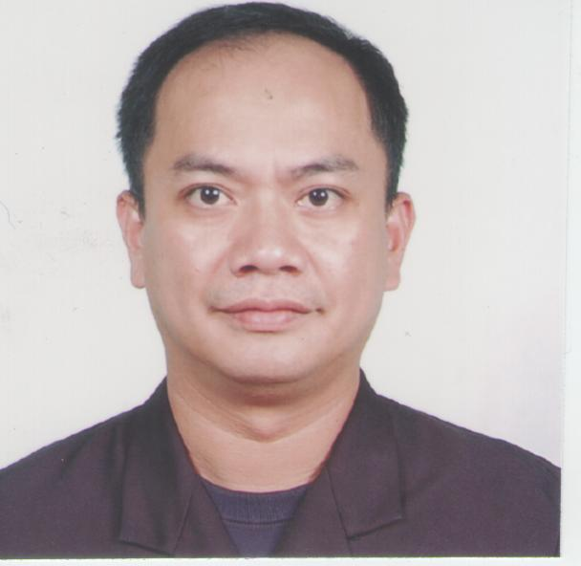
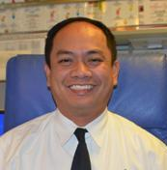
Jerome Octavious S. Mendoza

Block 59, Lot 14, Phase 4,
Dreamcrest Homes, Longos
Malolos City, Bulacan
Philippines 3000
+639209690716

OBJECTIVE: SEEK THE POSITION A
BAR SUPERVISOR/ASST. BAR MANAGER

EDUCATION DETAILS:

COLLEGE: 1987-1992
Radiologic Technology
St. Jude College

HIGH SCHOOL: March 1985
Metro Manila College

ELEMENTARY: March 1981
Novaliches Elementary School

WORK EXPERIENCE:

March 2015 – Present Asst. Bar Manager
Cruise and Maritime Voyages

Position Summary: In charge of nightshift bar operations. See to it that all guests are served and treated well. Making sure supplies are always check and updated for any shortages. Sees to it that bars are well maintained and cleaned during closing time. Do weekly rotation plan and make reports for daily operations.

Apr 7 2014 – Dec 24 2014 Bar Manager
Star Cruises

May 3 2013 – Feb 7 2014 Bar Manager
Star Cruises

May 4 2012 – June 6 2013 Asst. Bar Manager
Star Cruises

Position Summary: In charge of bar operations and scheduling of staff. Prepare daily operation reports and other paper works. Do trainings, seminars for bartenders and servers. Meet with the staff for weekly meetings, discussing and resolving problems on hand and making improvements to situations encountered.

July 2003 – August 2011 Bartender
Disney Cruise Line

Position Summary: Having a wide range of knowledge in bar concoctions. Bar costs and revenue knowledge. Responsible for delivering an exceptional bar experience for our guests with the ability to organize and coordinate the service to anticipate guest’s needs and exceed their expectations. A team player taking an active role in delivering an exceptional product while contributing to a positive environment. Maintain an open mind and willing to accept change by playing an active role in its development. Communicate in a clear and concise manner.

Responsibilities: Provide exceptional internal guest service. Follow USPH sanitation requirements. Maintain Guest Satisfaction Measurement. Involvement in team work to address Guest and Crew issues.
`
May 2001 – October 2002 Assistant Bar Manager
Star Cruises

Position Summary: Ensure the efficient and expected standard of work for each staff. Ensure the cleanliness and readiness of the outlet with sufficient supplies and stocks. Ensure that staff carried out their duties and services up to the guests’ expectation. Carried out management functions as expected by higher officials and staff as well.

November 1999 - 2000 Bar Supervisor
Star Cruises

Position Summary: Trains new staff on their duties and responsibilities. Ensure the staff’s awareness and product knowledge and of handling guests’ requests and complains. Assist with the management’s handling of the outlets’ daily operations.

November 1998 - 1999 Bar Captain
Star Cruises

Position Summary: Assist in handling guests’ orders and requests. Ensure the proper handling of orders and correctly given on guests’ tables. Reach the guests’ expectations of their needs.

November 1996 – 1998 Bartender
Star Cruises

Position Summary: Well rounded in providing a great knowledge in bar concoctions. Ensure that orders received and given to the guests’ are of above guests’ expectations. Aware and acts on guests’ needs and complains.
November 1995 – 1996 Waiter
Star Cruises

Position Summary: Assists guests to their table. Well-rounded in outlet’s menu and services. Ensure guests’ satisfaction in the service provided.
November 1994 – 1995 Housekeeping Attendant
Star Cruises

Position Summary: Ensure the cleanliness of cabin hallways and floors. Clean cabins and change linens. Attending on guests needs and requests.

SKILLS and KNOWLEDGE:

Well oriented and knowledgeable in bar concoctions, costs and revenues. Promotes and possess good leadership. Possess good communication skills. Have good relations with the guests. Computer literate with office works and equipment experience.

DOCUMENTS ON HAND:

Seafarer’s Identification and Record Book: Expiry date: 28 Dec 2021
Passport: Expiry date: 15 Apr 2029
UK Visa

Personal Information:

Date of Birth : October 1, 1969 Height : 5’6”
Place of Birth : Las Pinas City Status : Married
Age : 50 Citizenship : Filipino
Religion : Catholic

