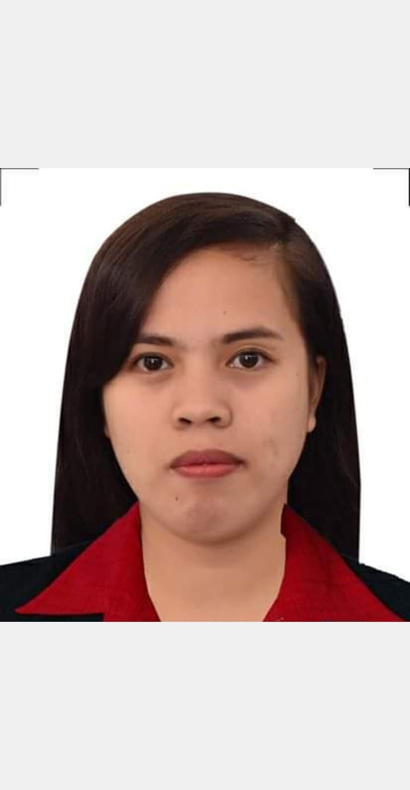
ANGELINE P. MANIBALE
Blk27 Lot 4 Southville 8A San Isidro Rodriguez Rizal
Mobile No. 09566179732
Email Address: angelinemanibale29@gmail.com

OBJECTIVE

To use my skills in the best possible way for achieving the goals of the company, to enhance my professional skill in a dynamic and fast paced workplace. Seeking a responsible job opportunity for professional challenges.

PERSONAL DATA

Date of birth : August 29, 1994
Place of birth : Ampid I, San Mateo Rizal
Status : Single
Citizenship : Filipino
Religion : Roman Catholic
Father’s Name : Noe T. Manibale
Mother’s Name : Jesebel P. Manibale
Language/Dialects Spoken : Filipino, English

EDUCATIONAL ATTAINMENT

Tertiary San Mateo Municipal College Guitnang Bayan II, San Mateo Rizal
Bachelor in Elementary Education
(2012-2016)

ICCT College
Gen. Luna St. Sta. Ana San Mateo, Rizal
Bachelor of Secondary Education Major in Pilipino
(2011-2012)

Secondary Jose F. Diaz Memorial National High School
Gulod Malaya, San Mateo, Rizal
(2007-2011)

Elementary Ampid I Elementary School
Sta. Maria, Ampid I, San Mateo Rizal
(2001-2007)

WORK EXPERIENCES

April 2015 : Assistant Teacher in Day Care Center
Summer Job, Special Program for Employment of student

December 2015-March 2016 : Pre-Service Training
Guitnangbayan Elementary School
August 2016-March 2017 : Elementary Teacher Domus Angeli Academy

May 2018-March 2020 : Elementary Teacher
Educational Values and Character Child Development Center INC.

SEMINARS ATTENDED

November 17, 2018 : Teaching Fostering Problem Solving Skills for Young Children

SKILLS/INTERESTS

- Computer Literate (PowerPoint, Excel, Word, Prezi)
- Singing, Dancing, Acting
- Teaching (Classroom management, record keeping, making exams)

CHARACTER REFERENCES

Jenny A. Atacador
09071223524
Administrative Aide
Departmentof Social Walfare and Development

Cherry B. Rañola
09489098788
Public Teacher
Guitnangbayan Elementary School

Pedro D. Enaje Jr.
09460675451
Electrician
Power Circle international. Inc.

Zaira Mae F. Sandoval
09356031862
Store Personnel
Rodmar Telecom

I hereby certify that the statement made in this application is true and correct.

MS. ANGELINE P. MANIBALE
Applicant

