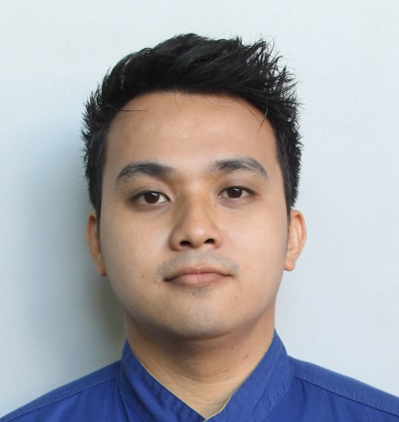
ROBERT JOE B. JAMILLA
34 Kia-Ora Parade Ferntree Gully Vic. 3156
0466335555
bert_joe_03@yahoo.com

OBJECTIVE: To obtain a position related to my chosen field of specialization and to enhance my creativity and knowledge in this field, as well as to gain necessary training and develop skill for career advancement and also to be able to find employment on a company with which I could contribute to its growth and development not only as an individual but also as a part of a group.

EDUCATIONAL ATTAINMENT
Tertiary
Emilio Aguinaldo College
Auto Servicing Nc1
28/05/2011

Secondary
Imus Institute
02/04/2006

WORKING EXPERIENCE
Auto Mechanic
25/09/2018 to present
Toyota Ferntree Gully
1101 Burwood Highway, Ferntree Gully Vic. 3156

Service Technician
18/12/2014 to 20/08/2018
Toyota Dasmariñas Cavite
Aguinaldo Highway Salitran Dasmariñas, Cavite Philippines 4114

Service Technician
03/10/2011 to 17/12/2014
Macro Staffing Inc.
905 Sabino Padilla St. Binondo, Manila Philippines 1008

DUTIES AND RESPONSIBILITIES
- Attend circle meeting
- Always performs 5’s and maintain cleanliness of workshop
- Perform preventive maintenance service
- Perform PDI (Pre-Delivery Inspection)
- Perform full wheel alignment
- Perform aircon cleaning / recondition
- Proper disposal of engine use oil
- Diagnose of engine and body electrical
- Repairing of under chassis
- Diagnose of MIL (Malfunction Indicator Light) using GTS, Intelligent Tester II
- Conduct a training for company / school OJT as a technician
- Inspect, diagnosing and repairing mechanism / system of gasoline and diesel engine using repair manual, EWD and tester (voltmeter, hand-held tester, intelligent tester ll, GTS)
- Perform overhauling of engine, transaxle/transmission, starter and alternator

TRAININGS
Toyota Professional Technician February 2020
Toyota Technician January 2020
Toyota Professional Technician (Philippines) 2016 to 2017
Toyota Technician (Philippines) 2014 to 2015

PERSONAL INFORMATION
Date of Birth: 03/11/1989 Birth Place: Imus, Cavite
Marital Status: Married Nationality: Filipino
Passport No.: P4282675A 06/09/2017 to 05/09/2022
In Case of Emergency: Cristine P. Jamilla +639177405193

CHARACTER REFERENCES
Krupesh Patel Michael Ponente Charles Kevin Jamolin
Job Controller Service Manager Auto Mechanic
Toyota Ferntree Gully Toyota Ferntree Gully Toyota Ferntree Gully
0430816701 0401737699 0431463070

