Jan-jan F. Abbas, RRT
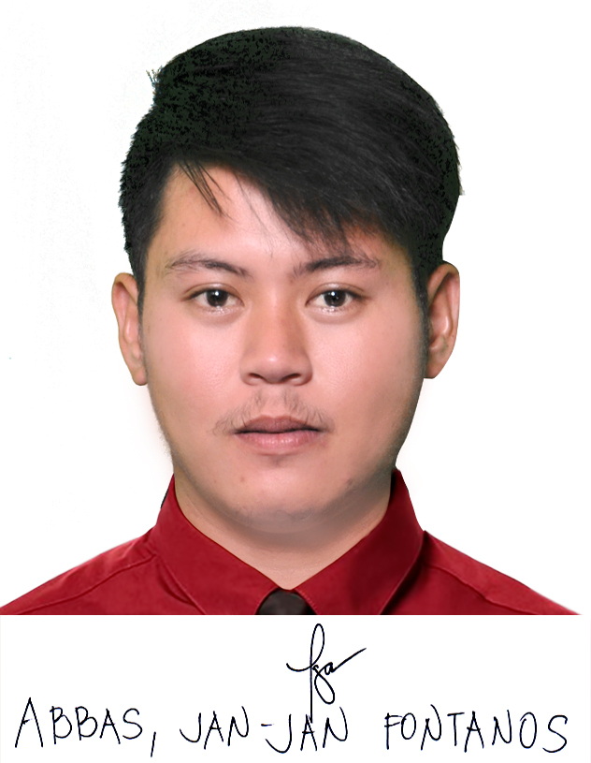
Address: # Baler, Aurora, Philippines
Mobile No.: 09283495488
Email address: jjabbas08@gmail.com

OBJECTIVE: To obtain a Radiologic Technologist position in your prestigious hospital and to challenge and strengthen my professional skills for achieving advancement and growth for the company.

PROFESSIONAL SKILLS:
- Bachelor’s Degree in Radiologic Technology Profession
- Proficient in Microsoft Office ( Word, Power point, Excel)
- Familiar with fixed and mobile radiography, CTs, MRIs and fluoroscopic procedures.
- Committed to providing high-quality radiologic services and catering to patient needs during exams. Proficient user of radiology management and hospital information systems.
- Organized – Excellent time management and prioritization skills.
- Take patient histories and explain specific exam details.
- Review discharge instructions with the patient.
- Perfect customer service skills.
- Ability to work under pressure and flexible.

PERSONAL DATA:
Age: 25 years old
Gender: Male
Date of Birth: March 10, 1995
Place of Birth: Cabanatuan City
Civil Status: Single
Citizenship: Filipino
Religion: Islam
Weight: 68 Kilograms
Height: 5’5(168m)

EDUCATIONAL ATTAINMENT:
Tertiary Bachelor's Degree in Radiologic Technology
The Good Samaritan Colleges
2011-2015

Secondary Wenceslao National High School
2008-2011

Primary Sto. Tomas Elementary School
2003-2008

WORKING EXPERIENCE:
Hospital: PREMIERE GENERAL HOSPITAL- SUKLAYIN, BALER
(Radiologic Technologist) August 2018-2019

MACHINE HANDLED
- General Electric DXS 550 TFX 15 Radiography System
- iCR 3600+ processor
- Automatic Processor

Hospital: Philippine Orthopedic Center – Quezon city
(Junior Internship From: May 2, 2014 – October 3, 2014)

MACHINE HANDLED
- Angel Portable x-ray
- Medien Digital radiography
- Automatic Processor

Hospital: Dr. Paulino J. Garcia Memorial Research and Medical Center
(Senior Internship From: November 2014- April 2015)

MACHINE HANDLED
- Apolo Digital Radiography system
- Shimadzu Radiography System
- Fijifilm FCR CAPSULA XLII + processor

SEMINARS ATTENDED:

Philippine Association of Radiologic Technologist (PART)
46 TH annual convention of P.A.R.T., Inc.: FROM X-RAY TECHNICIAN TO RADIOLOGIC TECHNOLOGIST PROFESSION)
(December 3-5, 2015)

Radiologic Technology National Convention (RT Natcon)
(November 8 to 10 2018)
“Upholding Continuing Education, Organizational Integration and Labor Economics for a Vigorous RT Profession.”

I.L.E.A.D Training center in partnership with medic center
Cabanatuan Chapter, Nueva Ecija
American Safety and Health Institute Training Center
‘’Basic life Support and Advanced Cardiac Life Support”,
(April 1 and 2 2019)

CHARACTER REFERENCES:

Mary Ann N. Bernardo, RRT Chieft Radiologic Technologist of
Immaculate Conception Medical Center
Nueva Ecija, Cabanatuan City
Contact No. 0955-9109-507
Email address: maryannnono_21@yahoo.com

Jomar C. De Guzman, RRT Radiologic Technologist I at
Philippine Orthopedic Center – Quezon city
Contact No. 0966-7089-553
Email address: jd0908886@gmail.com

Joriz F. Collado, RRT Former Faculty at Good Samaritan Colleges,
College of Allied and Health Professions.
Radtech/Ultasound tech. Associated Medical Enterprise Riyad, KSA.
Contact No. 0908-5846-007
Email address: collado.joriz@yahoo.com

I hereby certify that all above mentioned details are true and correct.
JAN-JAN F. ABBAS
RRT Applicant

