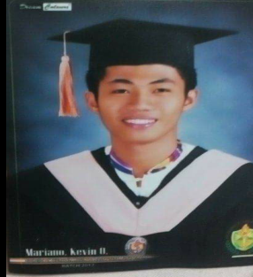
KEVIN ORPERIA MARIANO
ADDRESS: Villa Santiago Aglipay Quirino
Kevinmariano440@gmail.com
Phone #: 09057664229

OBJECTIVES: To contribute my expertise and knowledge in the company. To exert my full effort and accomplish my task in meeting the company’s goal and objectives.
PERSONAL DATA:
Date of Birth : November 22,1995
Place of Birth : Villa Santiago, Aglipay, Quirino
Civil Status : Married
Age : 22
Religion : Iglesia Ni Cristo
Nationality : Filipino
Height : 5’8
Weight : 65 kgs.
Language Spoken : Filipino, English
Father’s Name : Casimiro Ancheta Mariano Jr.
Occupation : Government Employee
Mother’s Name : Glorima Soncuan Orperia
Occupation : Teaching
EDUCATIONAL ATTAINMENT:
Tertiary : Bachelor of Science in Hotel and Restaurant Management
Quirino State University
Cabarroguis Campus
2013-2017
Secondary : Victoria High School
San Francisco, Aglipay, Qurino
2008-2012
Primary : Villa Santiago Elementary School
Villa Santiago, Aglipay, Quirino
2002-2008

SKILLS AND ATTRIBUTES:
Good communication skills
Computer literate
Can easily adopt on new environmental of work
Patient and honest`

TRAININGS AND SEMINARS:
ON THE JOB TRAINING (300 HRS) the enderun hospitality mngt.
PRIVATO HOTEL
706 Shaw boulevard,pasig city,phlipppines
On the job training (300 hrs)
Gaitoan hotel and restaurant

WORK EXPERIENCED:
Max’s Restaurant (gracefood resto corporation )
As a WAITER
Maharlika highway Villasis, Santiago City
Tel. no.:(078)305-3957
EXPONENT MOTOR CORPORATION [motoposh]
As a sales marketing coordinator and collector
Maddela quirino
CHARACTER REFERENCE:
CARINA D RUSTIA
College dean in hotel and restaurant management
QUIRINO STATE UNIVERSITY
CABARROGUIS CAMPUS
CP no. 09178951750
Janina rose L. Narag
Manager at maxs restaurant

I hereby certify to the truthfulness of the above given information to the best of my knowledge and understanding.

KEVIN O. MARIANO
Applicant

